Zabbix Setup

Version 6.4

August 16, 2023

Company Name - Address - Telephone - Email - www.website.com

© [Year] [Company Name] or a [Company Name] affiliate company. All rights reserved.

[Company] [Address]

[Phone] [Fax] [Website]

**Trademarks**

[Product Name] are registered trademarks of [Company]. All other trademarks or registered trademarks are the property of their respective owners.

**Disclaimer**

The information provided in this document is provided "as is" without warranty of any kind. [Company Name] disclaims all warranties, either express or implied, including the warranties of merchantability and fitness for a particular purpose. In no event shall [Company Name] be liable for any damages whatsoever including direct, indirect, incidental, consequential, loss of business profits or special damages, even if [Company Name] or its suppliers have been advised of the possibility of such damages.

**Document Lifetime**

[Company Name] may occasionally update online documentation between releases of the related software. Consequently, if this document was not downloaded recently, it may not contain the most up-to-date information. Please refer to www.[website].com for the most current information.

From the Web site, you may also download and refresh this document if it has been updated, as indicated by a change in this date: [Date].

**Where to get help**

[Company Name] support, product, and licensing information can be obtained as follows.

**Product** **information** — Documentation, release notes, software updates, and information about [Company Name] products, licensing, and service, are at [Company Name] website at:

http://www.[website].com

**Technical** **support** — Go to http://www.[website].com and select Support. On the Support page, you will see several options, including one for making a service request. Note that to open a service request, you must have a valid support agreement.

**Your comments**

Your suggestions will help us continue to improve the accuracy, organization, and overall quality of the user publications. Please send your opinion of this document to:

Documentation@[Company Name].com

If you have issues, comments, or questions about specific information or procedures, please include the title and, if available, the part number, the revision, the page numbers, and any other details that will help us locate the subject that you are addressing.

Preface

**Style Conventions**

The following style conventions are used in this document:

**Bold**

Names of commands, options, programs, processes, services, and utilities

Names of interface elements (such windows, dialog boxes, buttons, fields, and menus)

Interface elements the user selects, clicks, presses, or types

*Italic*

Publication titles referenced in the text

Emphasis (for example a new term)

Variables

Courier

System output, such as an error message or script

URLs, complete paths, filenames, prompts, and syntax

*Courier italic*

Variables on the command line

User input variables

< > Angle brackets enclose parameter or variable values supplied by the user

[ ] Square brackets enclose optional values

| Vertical bar indicates alternate selections - the bar means “or”

{ } Braces indicate content that you must specify (that is, x or y or z)

● Black dot is indicating bullet points. (Important)

-> Right arrow shows the next points in the document.

​​Table of Contents

***​***

1. **Introduction………………………………………………………………………………………………**
   1. Purpose of the Document……………………………………………………………………………….
   2. Reference of the document…………………………………………………………………………….
   3. Need for the Zabbix……………………………………………………………………………………….
   4. Advantages and disadvantages………………………………………………………………………
2. **Installation plan……………………………………………………………………………………….**
   1. Scope……………………………………………………………………………………………………………….
   2. Environment…………………………………………………………………………………………………….

**3. System Requirements**……………………………………………………………………………….

* 1. Software Requirements…………………………………………………………………………………….
  2. Hardware requirements…………………………………………………………………………………….

1. **Zabbix Installation**……………………………………………………………………………………….

4.1 Software requirements to install Zabbix on Ubuntu Server**………………………………………**

5. **Installing Zabbix Agent2 on Ubuntu 20.04…………………………………….**

5.1 How Zabbix agent works………………………………………………………

5.2 Pre-requisites………………………………………………………………………………………………...

5.3 Add the Zabbix Client to the Zabbix Server……………………………………………………

6. **Installing Zabbix Agent2 on CentOS 7**…………………………………………………

6.1 How Zabbix agent works………………………………………………………

6.2 Pre-requisites………………………………………………………………………………………………...

6.3 Add the Zabbix Client to the Zabbix Server……………………………………………………

7. **Installing Zabbix Agent2 on windows**………………………………………………

7.1 Manual Zabbix agent Installation……………………………………………………………………

7.2 Zabbix agent installation using MSI package………………………………………………….

7.3 Configure windows firewall and test Zabbix agent………………………………………

7.4 Add a Windows host on Zabbix Server……………………………………………………….

8. **Install and configure Zabbix proxy on ubuntu 20.04**……………………………………

8.1 Install Zabbix repository………………………………………………………………………….

8.2 Install Zabbix proxy………………………………………………………………………………….

8.3 Create Initial database…………………………………………………………………………….

8.4 Configure the database for Zabbix proxy…………………………………………………

8.5 Start Zabbix proxy process………………………………………………………………………

8.6 **Register proxy server in the Zabbix frontend……………………………………………**

## **8.7 Configure hosts in Zabbix to be monitored by a proxy………………………………**

**9. Zabbix Templates…………………………………………………………………………………….**

9.1 Advantages of Zabbix templates…………………………………………………………………………

9.2 Linux by Zabbix agent active ……………………………………………………….………..............

9.3 Nginx by HTTP……………………………………………………………………………………………………

9.4 Jenkins by HTTP……………………………………………………………………………………………...

9.5 Systemd by Zabbix agent2…………………………………………………………………………………

9.6 Generic Java JMX………………………………………………………………………………………………

9.7 Elastic Search cluster by HTTP………………………………………………………………………….

9.8 MSSQL by HTTP……………………………………………………………………………………………….

9.9 Website certificate by zabbix agent 2………………………………………………………………

**10. Frontend Sections……………………………………………………………………………….**

10.1 Problems……………………………………………………………………………………………………..

10.2 Hosts……………………………………………………………………………………………………………

10.3 Latest data……………………………………………………………………………………………………

10.4 Maps…………………………………………………………………………………………………………

**11. Zabbix Alerts: Setup Zabbix Email Notification……………………………………**

11.1 Office365………………………………………………………………………………………………………

11.2 webhook-Telegram……………………………………………………………………………………….

**12. Authentication (SAML)………………………………………………………….**

**13. User groups………………………………………………………………………...**

13.1 User roles…………………………………………………………………………………………………….

13.2 Users………………………………………………………………………………………………………….

**14. Dashboard…………………………………………………………………………….**

14.1 Global Dashboard………………………………………………………………………………………….

14.2 Create a dashboard………………………………………………………………………………………..

***​***

**​**

***​***

**​**

1 Introduction

Zabbix is an open-source software tool to monitor IT infrastructure such

as networks, servers, virtual machines, and cloud services.

● Zabbix collects and displays monitoring metrics such as network utilization, CPU load and disk space consumption.

● Zabbix is primarily designed for real-time monitoring.

* 1. Purpose of the Document

This Document explains how to work with Zabbix Monitoring tool.

● We will install all the relevant tools to create and manage the Zabbix server.

● We will be installing and configuring Linux, CentOS, Windows agents.

**Zabbix basic architecture:**

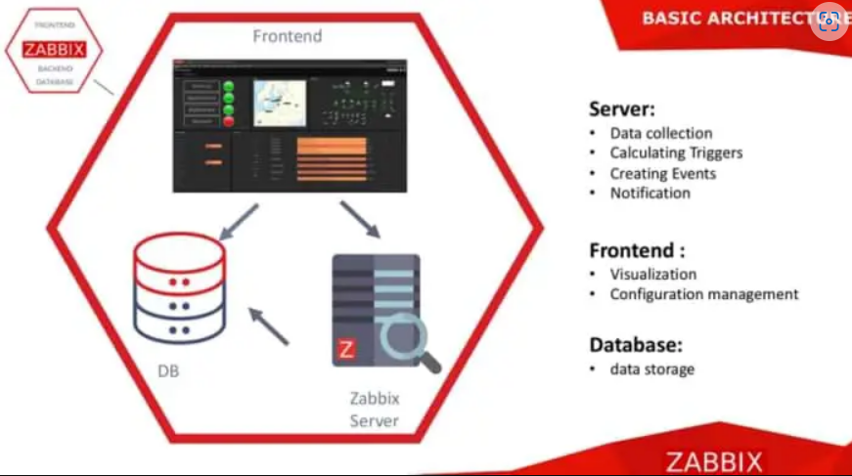

* 1. Reference of the document

**for further information refer the Zabbix official documentation:** [Zabbix :: The Enterprise-Class Open Source Network Monitoring Solution](https://www.zabbix.com/)

* 1. Need for Zabbix Monitoring Tool.

**Performance monitoring**: You receive information about resource loading, service availability, as well as warnings about possible problems or failures. This helps prevent potential problems and improve overall system performance.

**Notifications and Alerts**: Zabbix provides flexible notification settings that allow you to receive alerts about critical events and problems

1.4 Advantages.

● Cost-less platform.

● Reliable features like Zabbix agent, notification and remediation module.

● Easy-to-use and robust GUI.

● Allows users to configure e-mail-based alerts for virtually any event

● Excellent reporting and data visualization features based on archived data.

1.4 Disadvantages.

● Zabbix must include the Amazon RDS.

● Zabbix must provide more templates for rich monitoring.

1. Installation Plan

This is the Overlay of Creating and Managing the Zabbix monitoring software in different platforms.

* 1. Scope
* Network devices
* Cloud services, containers, virtual machines
* OS level monitoring
* Log files
* Databases
* Applications
  1. Environment

In Zabbix server setup we use Ubuntu machine to simulate a monitoring environment.

3. System Requirements:

Depending on the Operating system in use, the System Requirements of the Zabbix installation may vary.

**Zabbix can be downloaded in different ways based on platform selected.**

● Below are the different ways of installing Zabbix.

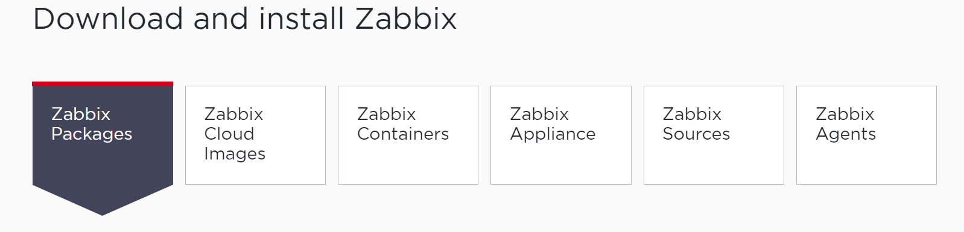

● we can download Zabbix in our standalone server as package installer.

● we can download Zabbix in cloud environments.

● we can download Zabbix in containers and so on.

3.1 Software Requirements

An Ubuntu Server

MySQL

● A web-server Nginx 6.0 or later,

→ Apache v1.3.12 or later.

An account with full root access.

3.2 Hardware Requirements

* 2 Core CPU
* 4 – 8 GB ram
* 50 GB Storage (SSD)
* Good Internet Connection

4 Zabbix Installation

We can choose the Installation based on platform.

Refer here for the official documentation:

[Download and install Zabbix 6.4 for Ubuntu 20.04 (Focal), MySQL, Nginx](https://www.zabbix.com/download?zabbix=6.4&os_distribution=ubuntu&os_version=20.04&components=server_frontend_agent&db=mysql&ws=nginx)

Here I have chosen the required components for Ubuntu distribution.

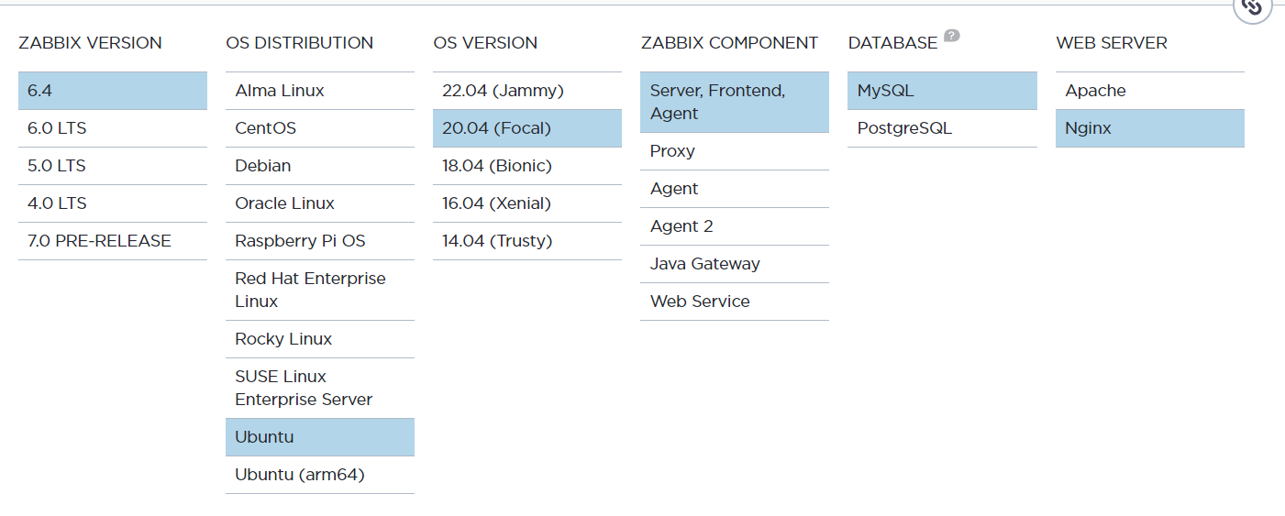

4.1 **Software requirements to install Zabbix on Ubuntu Server**

● latest Zabbix version 6.4.

● Operating System - Ubuntu 20.04

● Zabbix Component - Server, Frontend, Agent.

● Database - MySQL

● Webserver – Nginx

Now, let us install and configure Zabbix for our platform.

1. **Install Zabbix repository.**

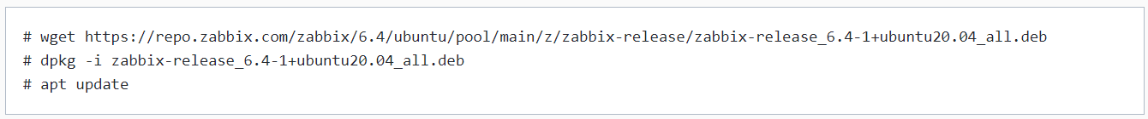

1. **Install Zabbix server, frontend, agent.**



##### Create a database.

Make sure we have database server up and running.

Run the following on our database host.

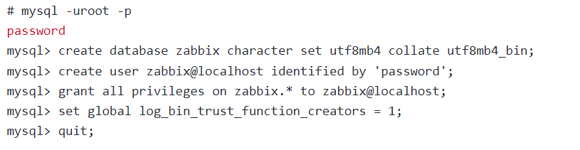

**On Zabbix server host import initial schema and data. we will be prompted to enter your newly created password.**



**Disable log_bin_trust_function_creators option after importing database schema.**

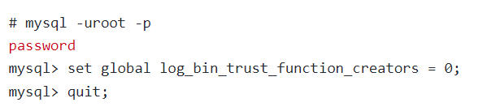

**d. Configure the database for Zabbix server**

Edit file /etc/zabbix/zabbix_server.conf

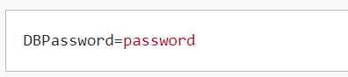

**e. Configure PHP for Zabbix frontend**

Edit file /etc/zabbix/nginx.conf uncomment and set 'listen' and 'server name' directives.

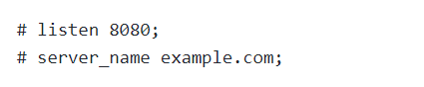

**f. Start Zabbix server and agent processes**

Start Zabbix server and agent processes and make it start at system boot.

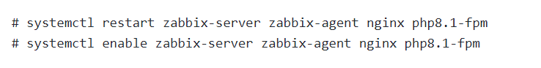

**g. Open Zabbix UI web page.**

**Open the zabbix login page by entering <public-IP/Zabbix>**

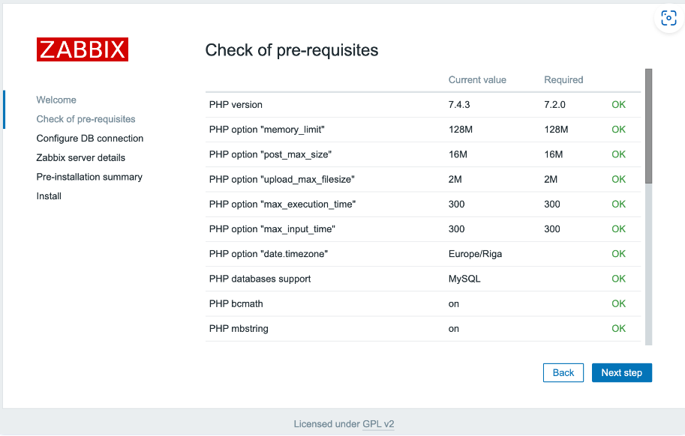

All of the values in this table must be **OK**, so verify that they are. Be sure to scroll down and look at all of the prerequisites. Once you’ve verified that everything is ready to go, click **Next step** to proceed.

The next screen asks for database connection information.

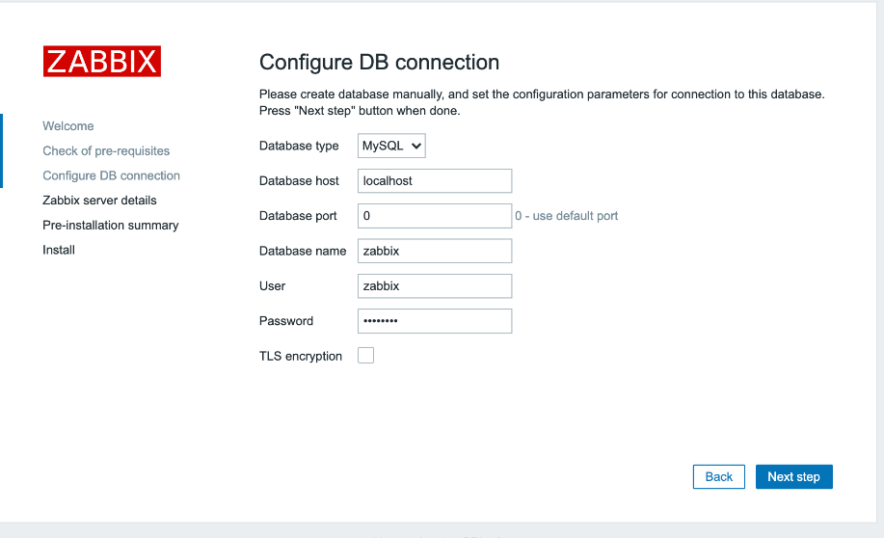

You told the Zabbix server about your database, but the Zabbix web interface also needs access to the database to manage hosts and read data. Therefore, enter the MySQL credentials you configured in Step 2. Click **Next step** to proceed.

On the next screen, you can leave the options at their default values.

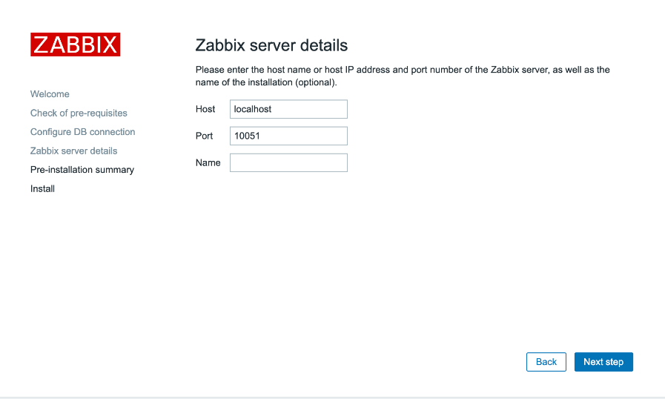

The **Name** is optional; it is used in the web interface to distinguish one server from another in case you have several monitoring servers. Click **Next step** to proceed.

The next screen will show the pre-installation summary so you can confirm everything is correct.

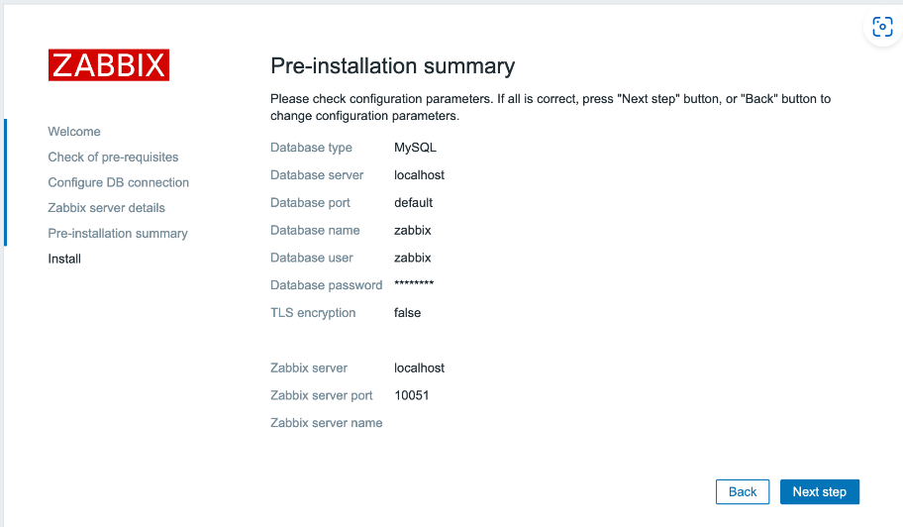

Click **Next step** to proceed to the final screen.

The web interface setup is now complete. This process creates the configuration file /usr/share/zabbix/conf/zabbix.conf.php, which you could back up and use in the future. Click **Finish** to proceed to the login screen. The default user is **Admin** and the password is **Zabbix**.

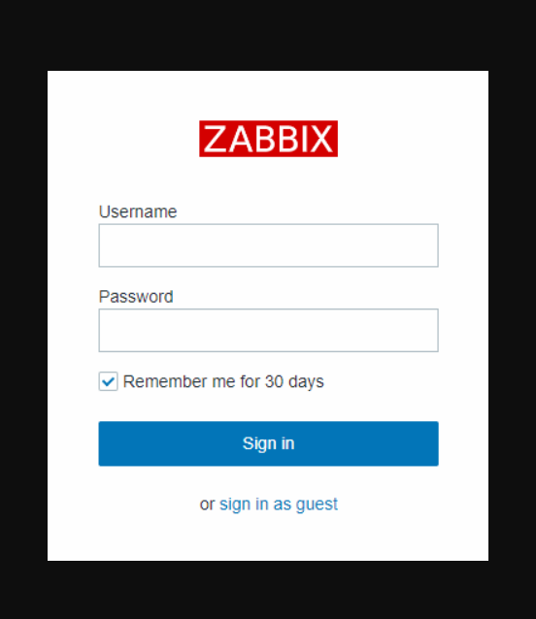

5. Installing Zabbix Agent2 on Ubuntu 20.04

● Zabbix is a powerful open-source monitoring software that allows you to monitor the servers, networks, and applications.

● In this documentation I will be installing Zabbix agent on Ubuntu 20.04.

● The Zabbix Agent is responsible for collecting system data and sending it to the Zabbix server for further analysis and storage.

5.1 How Zabbix agent works:

Zabbix agent can do both passive **(polling)** and active checks **(trapping)**.

The checks can be performed at an interval or based on specific times schedule. Here is the difference between passive and active checks:

**Passive checks (polling):**

● Zabbix server (or proxy) requests a value from Zabbix agent.

● Agent processes the request and returns the value to Zabbix server (or proxy).

**Active checks (trapping):**

● Zabbix agent requests from Zabbix server (or proxy) a list of active checks.

● The agent sends the results in periodically.

Picture that clearly explains about active and passive agents:

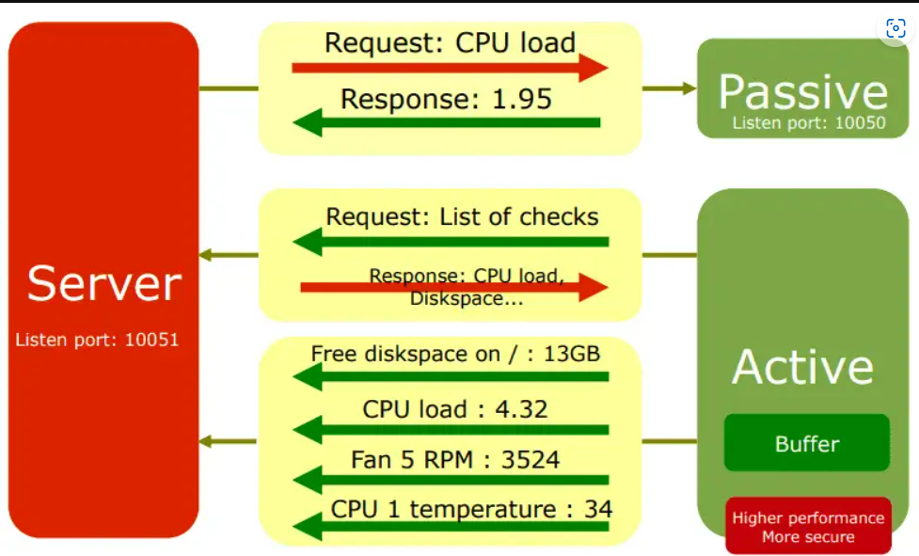

5.2 Prerequisites:

→ Ubuntu server 20.04 or desktop instance.

→ A user account with sudo privileges.

→ Zabbix server up and running.

**Step 1: Update your system:**

Before starting the installation process, It is always recommended to update your system. Open a terminal and execute the following commands.



**Step 2: Install Zabbix agent:**

**Note:** Here, when I am using zabbix 6.4 is the latest version.

Now, we will install the Zabbix Agent from the official Zabbix repository. First, add the Zabbix repository to your system.

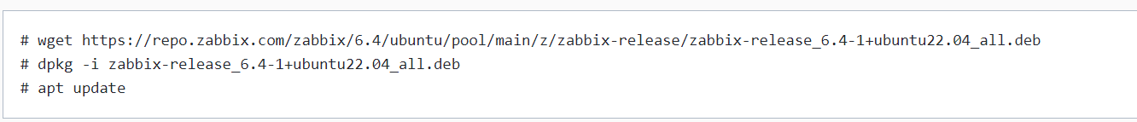

**Next, Install the Zabbix agent2:**

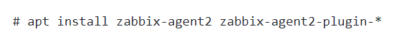

**Step 3: Configure Zabbix Agent:**

After the installation is complete, you need to configure the Zabbix Agent to communicate with the Zabbix server. Edit the Zabbix Agent configuration file using your preferred text editor:



Find the following lines and replace them with the correct information:

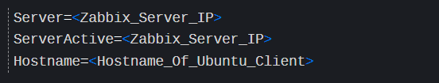

**Step 4: Start and Enable Zabbix agent2 process:**

Start Zabbix agent2 process and make it start at system boot.

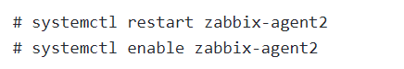

If you have ufw enabled, allow port 10050 on the firewall. This is used by Zabbix agent daemon.

# sudo ufw allow 10050/tcp

**You can check the status of the Zabbix Agent service with the following command:**

# sudo systemctl status zabbix-agent

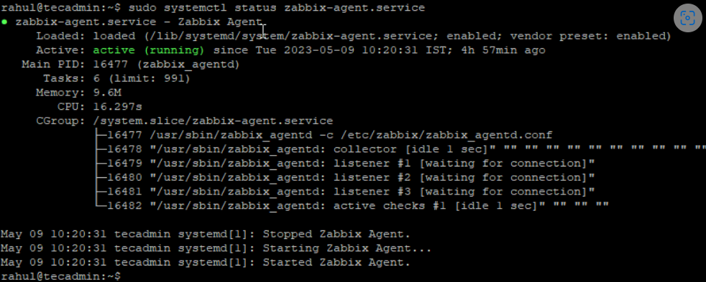

5.3 Add the Zabbix Client to the Zabbix Server:

→ Lastly, you need to add the newly installed Zabbix Agent to the Zabbix server.

→ Log in to the Zabbix web interface, navigate to “**Configuration**” > “**Hosts**” > “**Create Host**”, and fill in the necessary details.

→ Select the **group** or **add a new group** for “**Groups**” field. **IP address** Zabbix agent service port -default is **10050.**

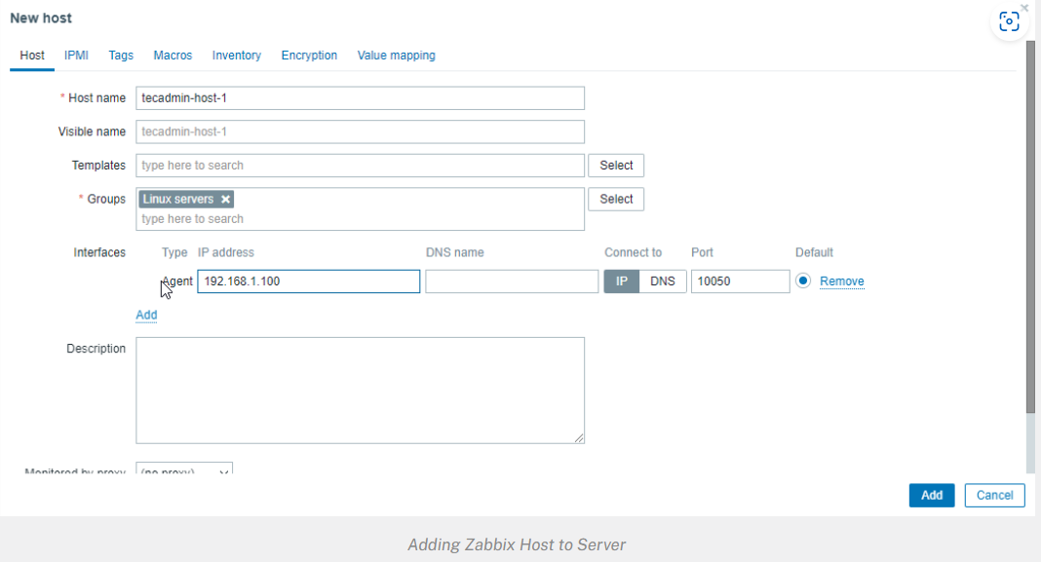

Then go to **Templates** tab.

1. Click the select button and Link new templates section

Select the template you want to use.

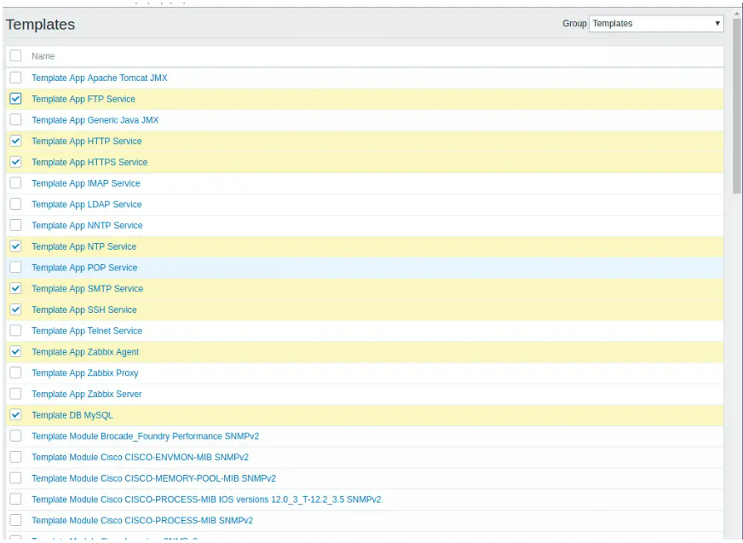

Once you have selected the templates click on the **Add** link to link templates to your target system After the templates are linked, they’ll appear on under **Linked templates** section

Refer here for [Templates](https://www.zabbix.com/integrations?cat=official_templates)

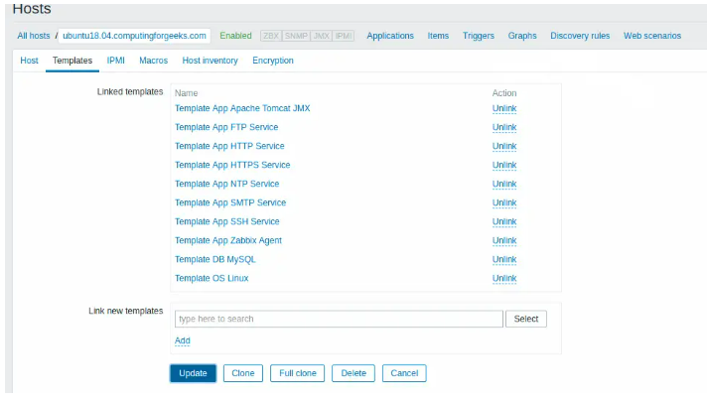

Update the setting using **Update** button. After few minutes, monitoring data will be collected and you can visualize them using Zabbix graphs.

The **Tags** tab allows you to define host-level [tags](https://www.zabbix.com/documentation/current/en/manual/config/tagging). All problems of this host will be tagged with the values entered here.

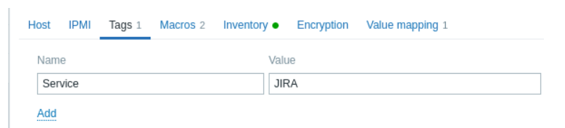

**User macros:** {INVENTORY. *} macros, {HOST.HOST}, {HOST.NAME}, {HOST.CONN}, {HOST.DNS}, {HOST.IP}, {HOST.PORT} and {HOST.ID} macros are supported in tags.

The **Macros** tab allows you to define host-level [user macros](https://www.zabbix.com/documentation/current/en/manual/config/macros/user_macros) as a name-value pairs. Note that macro values can be kept as plain text, secret text or Vault secret. Adding a description is also supported.

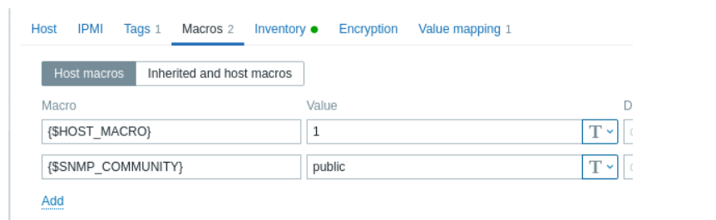

**Monitoring > Graphs > <Host|Graph>**

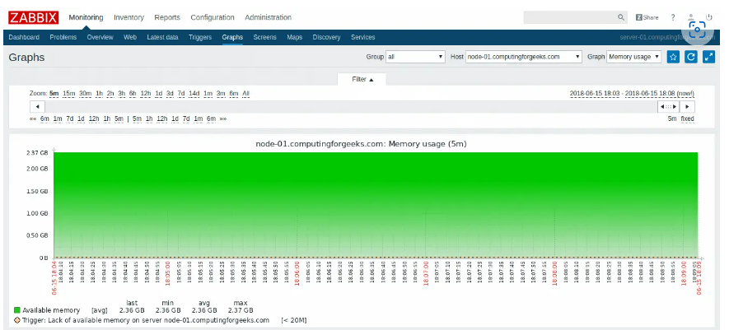

6 Installing Zabbix Agent2 on CentOS 7

● Zabbix is a powerful open-source monitoring software that allows you to monitor the servers, networks, and applications.

● In this documentation I will be installing Zabbix agent on Ubuntu 22.04.

● The Zabbix Agent is responsible for collecting system data and sending it to the Zabbix server for further analysis and storage.

6.1 How Zabbix agent works:

Zabbix agent can do both passive **(polling)** and active checks **(trapping)**.

The checks can be performed at an interval or based on specific times schedule. Here is the difference between passive and active checks:

**Passive checks (polling):**

● Zabbix server (or proxy) requests a value from Zabbix agent.

● Agent processes the request and returns the value to Zabbix server (or proxy).

**Active checks (trapping):**

● Zabbix agent requests from Zabbix server (or proxy) a list of active checks.

● The agent sends the results in periodically.

Refer here for the documentation <https://tecadmin.net/install-zabbix-agent-on-centos-rhel/>

This will give the clear idea about active and passive agent:

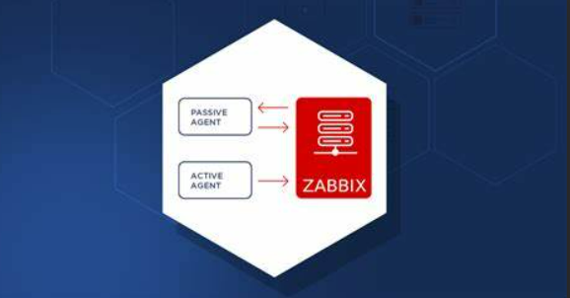

6.2 Prerequisites:

→ CentOS server 7 or desktop instance.

→ A user account with sudo privileges.

→ Zabbix server up and running.

**Step 1 – Add Required Repository:**

Before installing Zabbix Agent first configure Zabbix yum repository using following commands as per your required version and operating system.



**Step 2: Install Zabbix agent:**

**Note:** Here, when I am using zabbix 6.4 is the latest version.

After installing yum repository packages in our system. Use the following command to install Zabbix agent on your CentOS and Red Hat systems using the yum package manager.



**Step 3: Edit the configuration file**

As Zabbix agent has been successfully installed on our remote system. Now we just need to configure Zabbix agent by adding Zabbix server IP to the configuration file **/etc/zabbix/zabbix_agentd.conf**

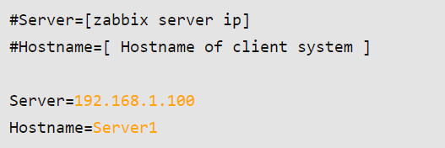

**Step 4: – Open Port**

Zabbix agent uses 10050/tcp port. You are required to open this port to allow the Zabbix server with the agent. Execute command to open port in iptables firewall where 192.168.1.100 is IP of Zabbix server.

# iptables -A INPUT -p tcp -s 192.168.1.100 --dport 10050 -m state --state NEW,ESTABLISHED -j ACCEPT

**Step 5: Restarting Zabbix agent:**

After adding Zabbix server IP to the configuration file, now restart agent service to reload the new settings, using the following command.



To start and stop zabbix-agent service anytime use following commands.

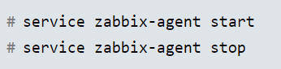

6.3 Add the Zabbix Client (Agent) to the Zabbix Server:

→ Lastly, you need to add the newly installed Zabbix Agent to the Zabbix server.

→ Log in to the Zabbix web interface, navigate to “**Configuration**” > “**Hosts**” > “**Create Host**”, and fill in the necessary details.

→ Select the **group** or **add a new group** for “**Groups**” field.

**IP address**

Zabbix agent service port -default is **10050**



Then go to **Templates** tab.

1. Click the select button and Link new templates section

Select the template you want to use.

Refer here for [Templates](https://www.zabbix.com/integrations?cat=official_templates)



Once you have selected the templates click on the **Add** link to link templates to your target system After the templates are linked, they’ll appear on under **Linked templates** section



Update the setting using **Update** button. After few minutes, monitoring data will be collected and you can visualize them using Zabbix graphs.



7 Installing Zabbix Agent2 on windows

● We install the Zabbix agent in monitoring hosts to monitor resources and applications.

Zabbix server can actively alert the administrators. Also, has a web interface to manage the alerts.

● Agents can perform passive and active checks.

There are two methods to install Zabbix agent on windows.

* 1. **Manual** Zabbix agent Installation.
  2. Zabbix agent installation using **MSI package**.

Refer here for the opensource documentation <https://www.tecmint.com/install-zabbix-agent-and-add-windows-host-to-zabbix-monioring/>

Refer here for the official Zabbix documentation: [Zabbix official documentation](https://www.zabbix.com/download_agents?version=6.4&release=6.4.6&os=Windows&os_version=Any&hardware=amd64&encryption=No+encryption&packaging=Archive&show_legacy=0).

7.1 Manual Zabbix agent Installation:

Let’s have a brief look into the manual Zabbix agent installation.

1. First, we download the Zabbix agent for the Windows-based on the architecture and hardware used.

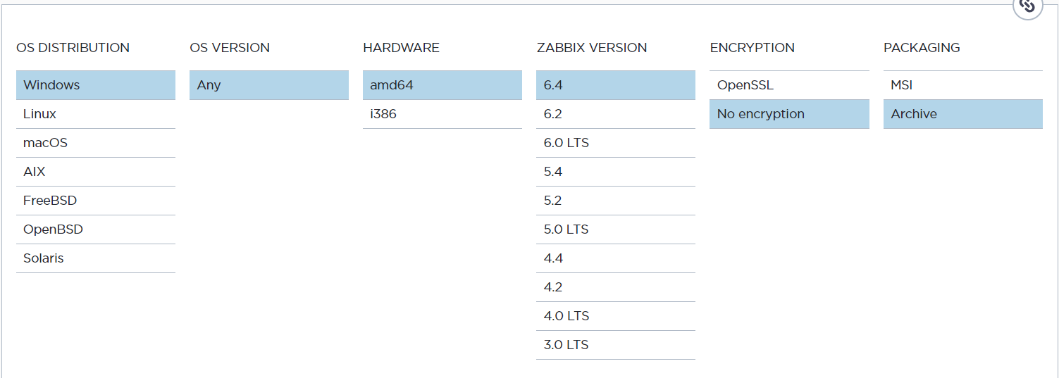

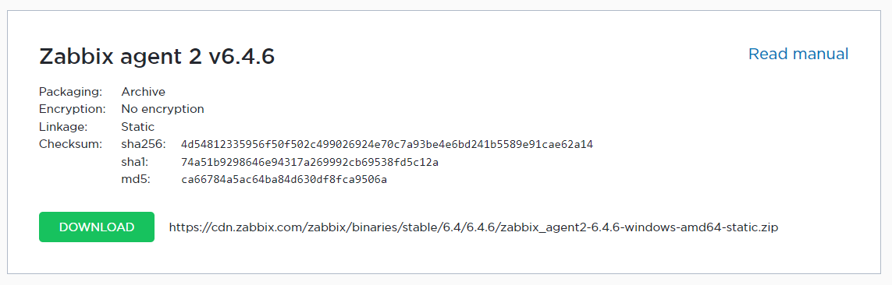

1. Then to install the Zabbix agent we open CMD as administrator.
2. We move to the directory where the files are been downloaded. Then, we run the below command:

zabbix_agentd.exe --config zabbix_agentd.conf –install

An installation success message appears.

1. Now we open **zabbix_agentd.win.conf** file and make changes in the following parameters:

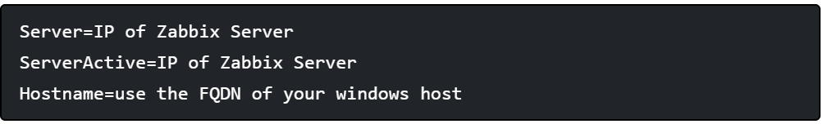

1. Next, we start the Zabbix agent. For that, we use the command,

zabbix_agentd.exe –start

To stop the service run the same command as above with --stop argument and to uninstall the service use the --uninstall argument.

zabbix_agentd.exe –-stop

Zabbix_agent.exe --uninstall

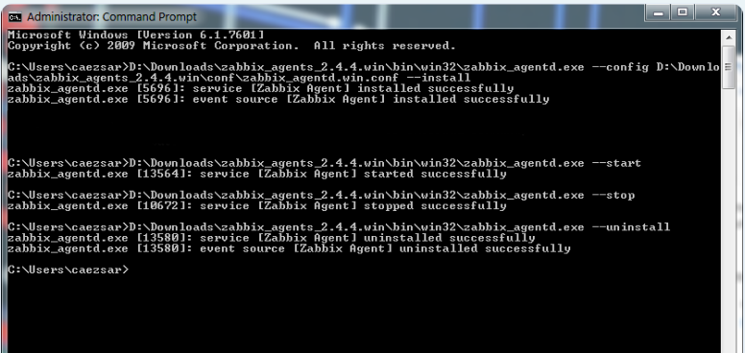

### 7.2 Zabbix agent installation using MSI package

### A second and more convenient method to install and automatically configure the Zabbix agent on Windows environments is by downloading the Zabbix Agent installer **MSI** package specific to your system architecture.

* 1. Install the MSI package from the official Zabbix website.

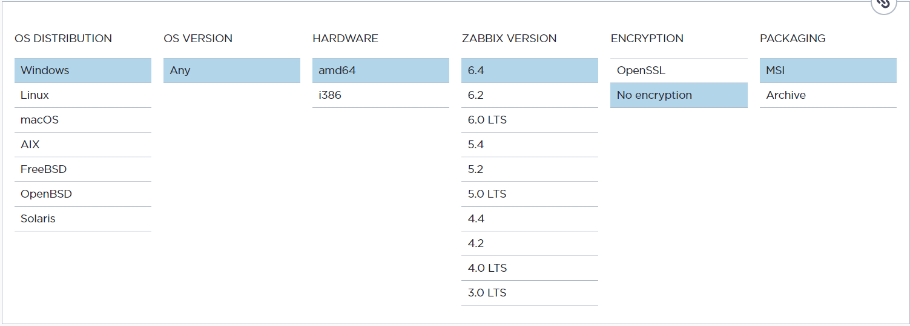

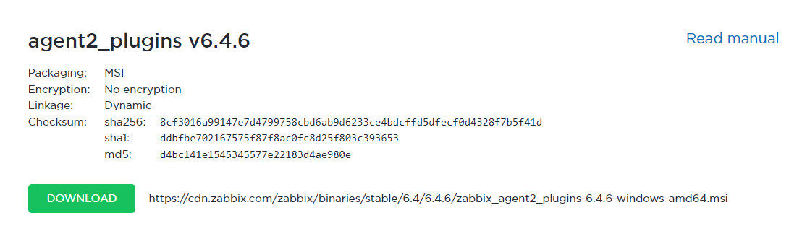

Once the Zabbix agent **MSI** file has been downloaded on your system, run it and supply the required information in order to configure and install the agent on the target monitored host as it follows:

**Hostname**: FQDN of your windows host

**Zabbix server Name**: IP of the Zabbix Server

**Agent Port**: 10050

Check the remote command box

**Active Server**: IP of Zabbix Server

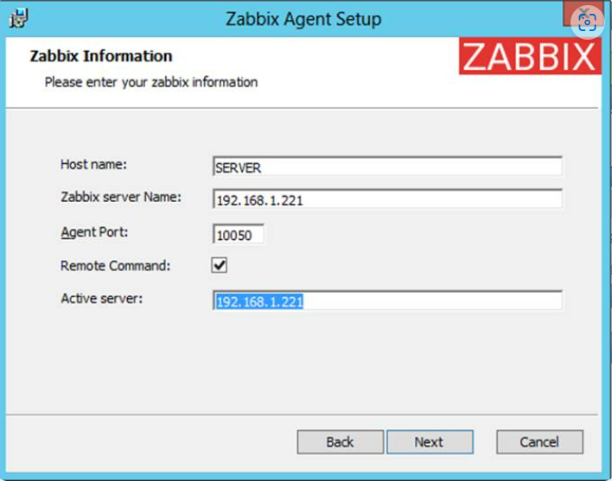

* 1. Then, click next. Now we give the default file location and finish the setup.
  2. Then, we check the Zabbix agent service.
  3. If you need to modify the Zabbix configuration file with other custom values at a later date, the conf file can be found on the **%programfiles%\Zabbix Agent\** path.
  4. After you’ve finished the setup, open Windows **Command Prompt** with **Administrator** privileges, run **services.msc** command in order to open **Windows Services utility,** and locate **Zabbix** Agent service to check if the service is running and automatically started after reboot.

services.msc

From this console, you can manage the service (start, stop, pause, resume, enable or disable).

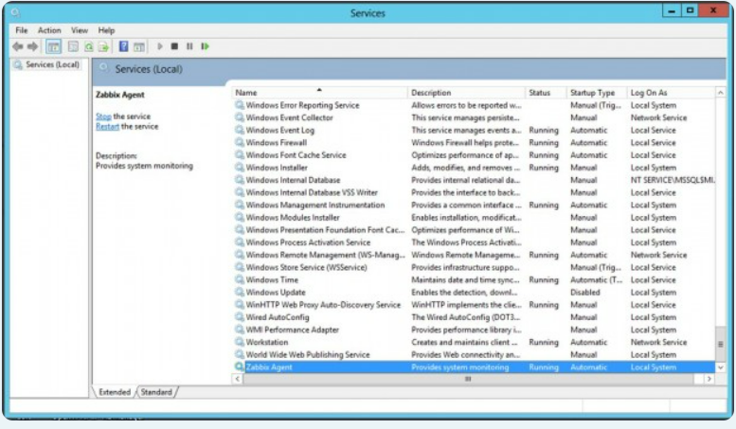

### 7.3 Configure Windows Firewall and Test Zabbix Agent

 Almost all Windows-based systems have **Windows Firewall** active and running, therefore Zabbix agent port must be opened in the firewall in order to communicate with the Zabbix server.

1. In order to open the Zabbix agent port in the windows firewall, open **Control Panel** -> **System and Security** – > **Windows Firewall** and hit on **Allow** an app through Windows Firewall.

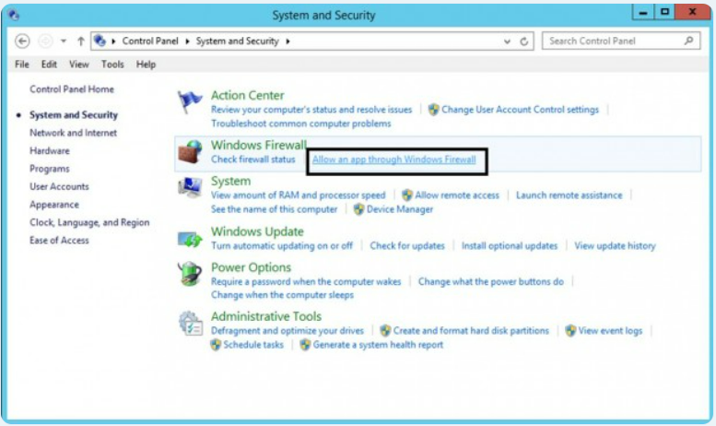

**2** Next, click on **Allow** another app button and a new window should open. Use the **Browse** button to navigate and add **Zabbix** agent executable file (usually found in **%programfiles%\Zabbix Agent\** if you installed it using MSI program), then hit on **Add** button to add the service.

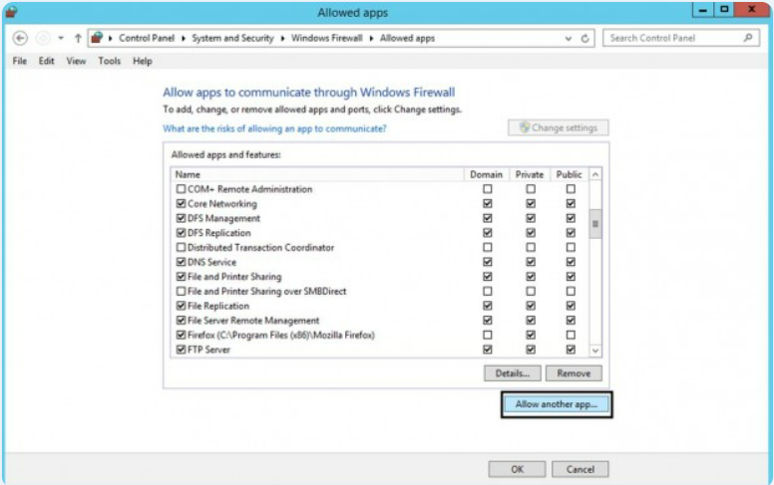

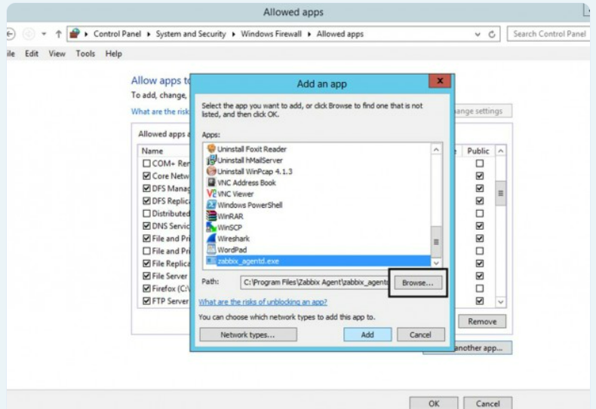

3 Next, make sure you check and open the firewall rule on the network segment where the Zabbix server is located in your network and hit the OK button to finish and apply the configuration.

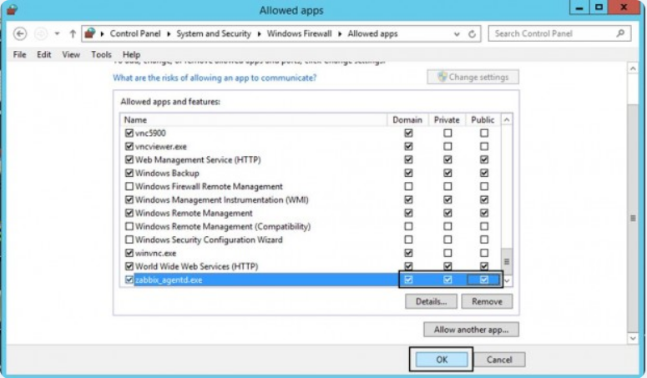

1. In order to test if the Zabbix agent running on windows is reachable from the Zabbix server-side, use **telnet** or **netcat command** on Zabbix server against windows agent **IP-Port** and a Connected message should appear.
2. Hit **Enter** key to generate an error message and automatically disconnect from the agent:

telnet <Windows_agent IP Address> 10050

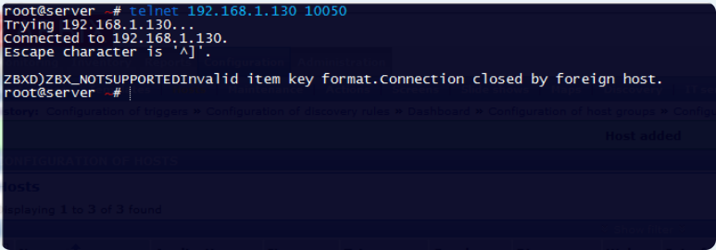

7.4 Add a Windows host on Zabbix Server:

**1**. To add a Windows host, go to **Configuration** –> **Host** –> **Create Host**

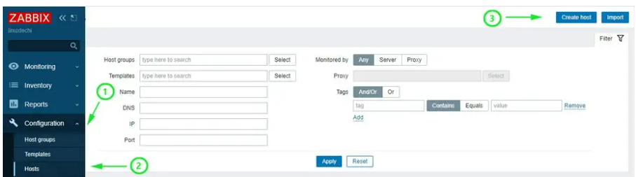

On the next screen, fill out the Windows host details such as hostname, visible name and IP address.

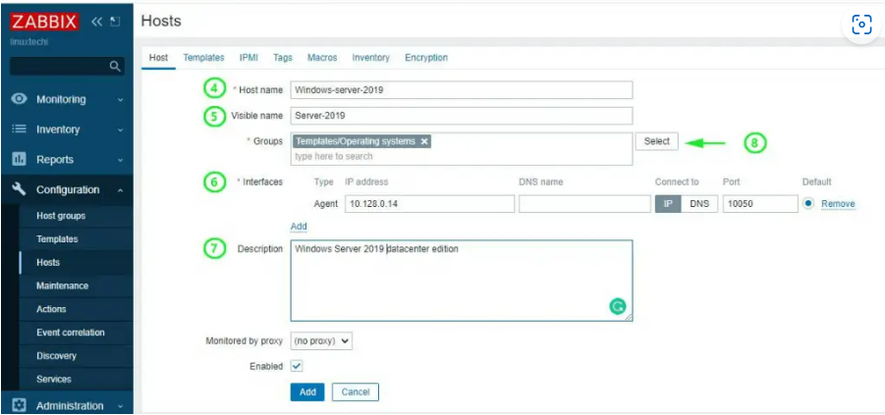

For the ‘**Groups**’ section, click on the ‘**Select**’ button and click on the ‘**Templates/Operating system**’ option.

Refer here for [Templates](https://www.zabbix.com/integrations?cat=official_templates)

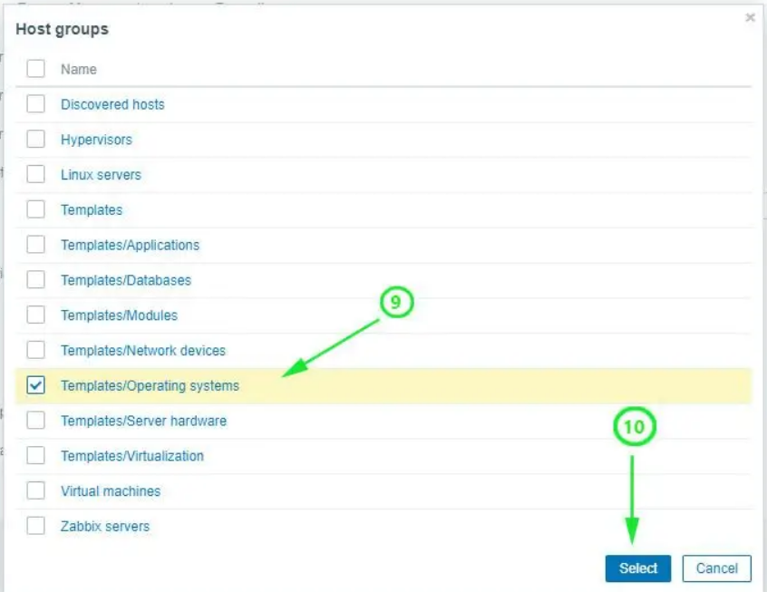

Next, click on the ‘**Templates**’ tab on the menu and click ‘**Template OS Windows by Zabbix agent**’. Finally, click on the ‘**Select**’ button.

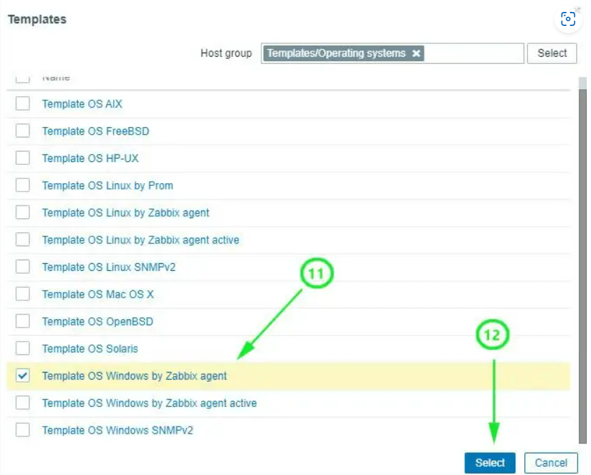

On the dashboard, check the Windows host listed as shown below. Note that the state is indicated ‘**Enabled**’ with the Zabbix icon ‘**ZBX**’ in green color.

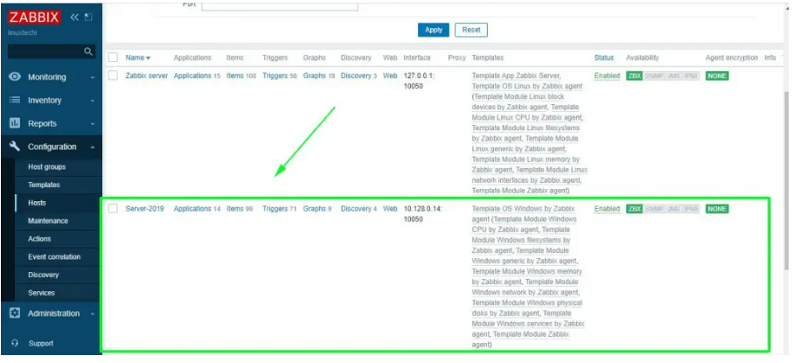

To graph the metrics associated with the Windows host system, click on ‘**Monitoring**’ –> ‘**Hosts**’. Click on the Windows host and select ‘**Graphs**’.

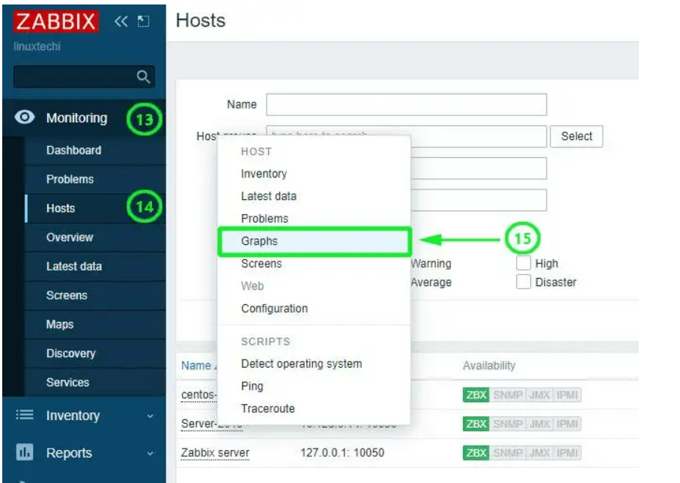

Finally, the Zabbix server will start graphing the system metrics shipped by the Zabbix agent which is residing on the Windows server host system. There are various metrics that you can monitor including network Interface statistics, CPU usage and utilization, Disk space usage and Memory utilization to mention a few.

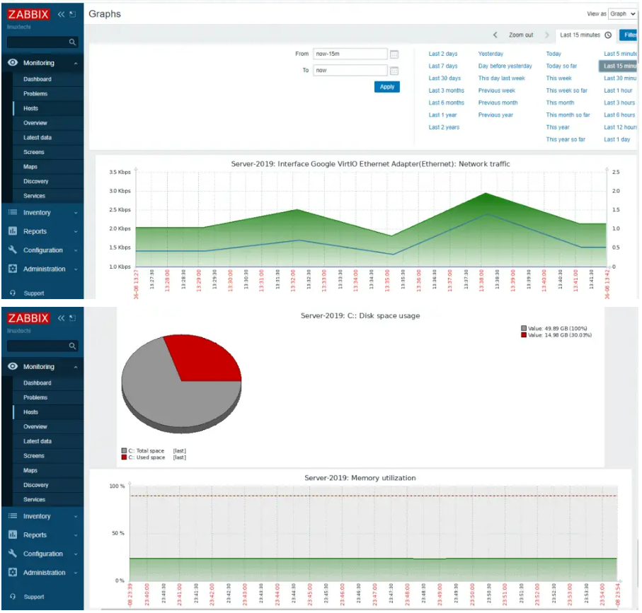

8. Install and configure Zabbix proxy on ubuntu 20.04.

● Zabbix proxy is a service that can collect performance and availability data from the end devices on behalf of the Zabbix server.

● You can use Zabbix proxy to monitor remote locations behind the firewall or locations that have unreliable communication and to offload the Zabbix server in large environments.

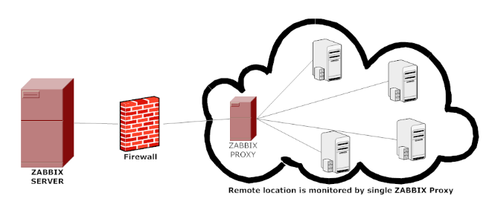

Refer here for the official documentation [Download and install Zabbix 6.4 for Ubuntu 20.04 (Focal), MySQL](https://www.zabbix.com/download?zabbix=6.4&os_distribution=ubuntu&os_version=20.04&components=proxy&db=mysql&ws=)

Note: Zabbix server and Zabbix proxy should maintain the same version, here

I am using

Zabbix Version = 6.4

Zabbix Proxy Version = 6.4

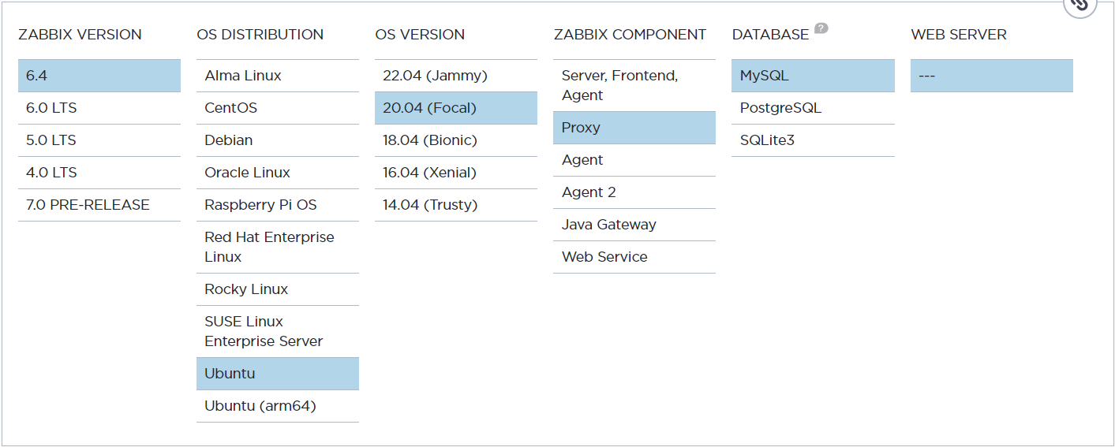

##### 8.1 Install Zabbix repository



##### 8.2 Install Zabbix proxy



##### 8.3 Create initial database

Make sure you have database server up and running.

Run the following on your database host.

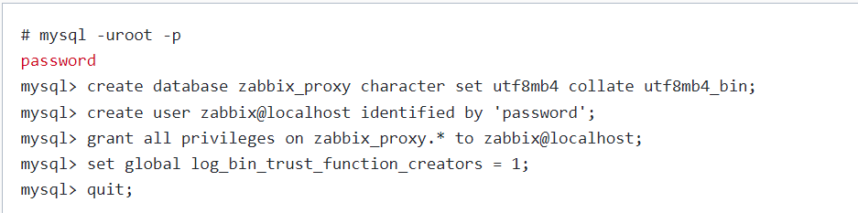

On Zabbix server host import initial schema and data. You will be prompted to enter your newly created password.



Disable log_bin_trust_function creators’ option after importing database schema.

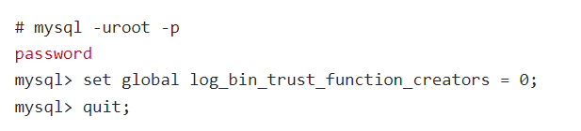

8.4 Configure the database for Zabbix proxy

Edit file /etc/zabbix/zabbix_proxy.conf

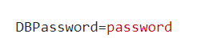

##### 8.5 Start Zabbix proxy process

Start Zabbix proxy process and make it start at system boot.

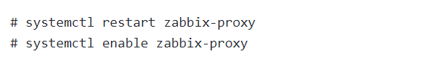

## 8.6 **Register proxy server in the Zabbix frontend**

Now that your proxy server is running, you need to register it in the Zabbix frontend using “**Proxies**” option under the “**Administration**” section. Click on the “**Create proxy**” button on the right, then set “**Proxy name**” to Zabbix proxy 01 and “Proxy mode” to “Active”.

Note that for a proxy to work in active mode “Proxy name” must be the same as the “hostname” parameter in “**zabbix_proxy.conf”** file**.**

Refer here for the documentation[Zabbix Proxy: Install on Ubuntu 22.04 / 20.04 in 10 minutes! (bestmonitoringtools.com)](https://bestmonitoringtools.com/install-zabbix-proxy-on-ubuntu/)

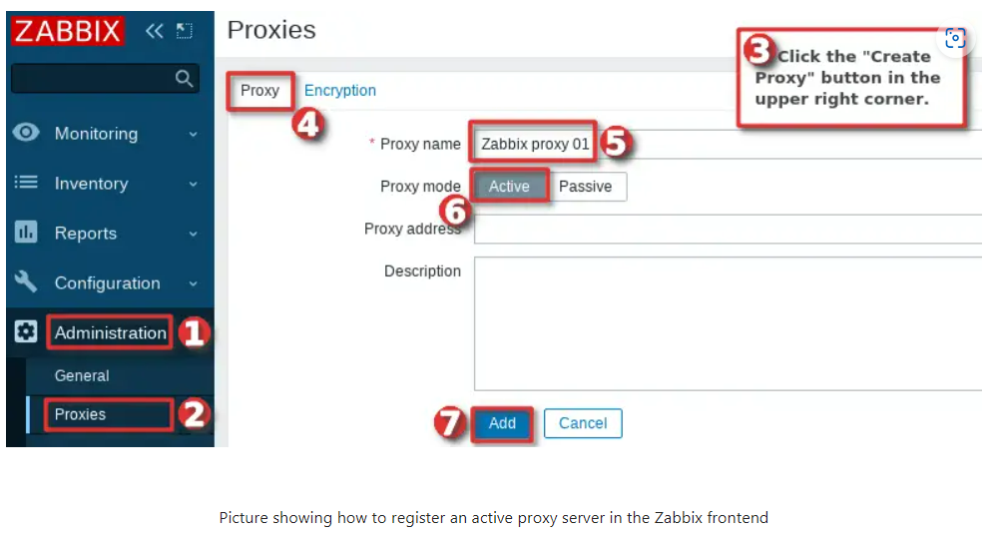

Immediately after adding a proxy to the frontend, you will be informed that the proxy has never been seen.



However, if you wait for 100 seconds “Last seen (age)” status will display seconds instead “Never” which means that proxy is communicating with the Zabbix server.



Why 100 seconds? Remember what we have put under the “ConfigFrequency” parameter in “zabbix_proxy.conf” file? Whatever you put there that’s how long will it take for the proxy to contact the Zabbix server to retrieve configuration data. This rule only applies if the proxy is in active mode.

Note that “Last seen (age)” status should never go above 6 seconds if proxy-server communication is working.

## 8.7 **Configure hosts in Zabbix to be monitored by a proxy**

Zabbix proxy is running and communicating with the Zabbix server, but it is not gathering any data because we didn’t do the last crucial step! We need to configure hosts in Zabbix to be monitored by the proxy server.

Let’s do that together, go to the “Host” option under the “Configuration” section and select hosts that need to monitored by the proxy server.

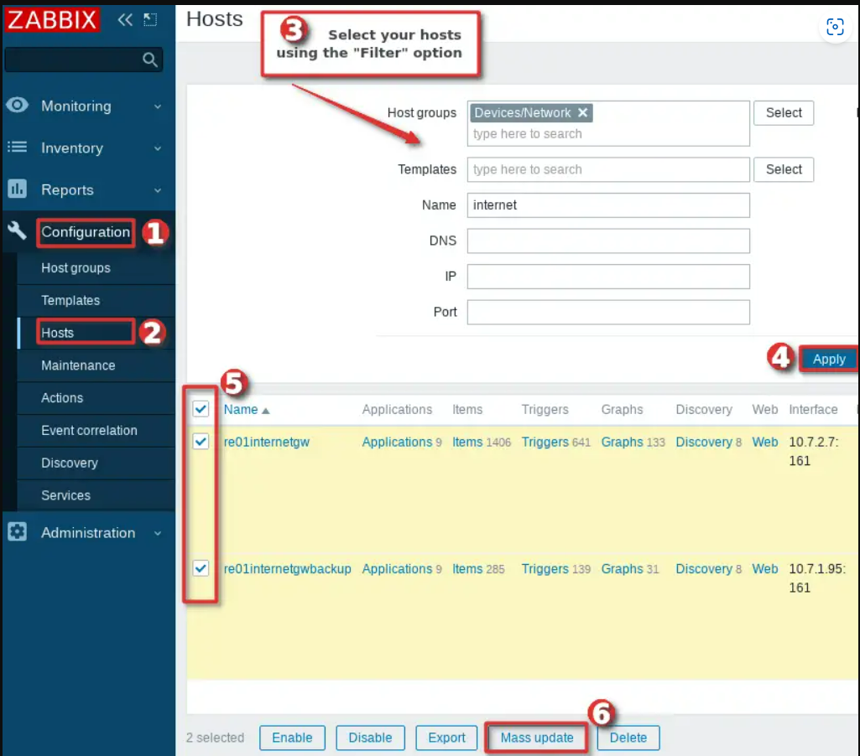

After you have selected hosts click on the “Mass update” button, then under the “Host” options select our newly added proxy in the “Monitored by proxy” dropdown and finally click the “Update” button just as shown in the image below.

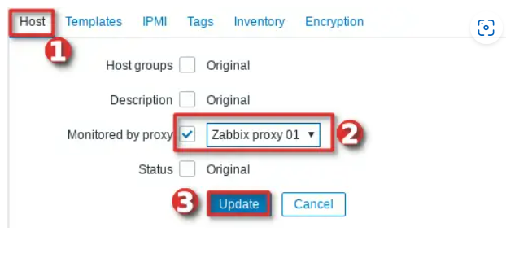

You have successfully Installed and configured Zabbix proxy on ubuntu!

9 Zabbix Templates

The use of templates is an excellent way of reducing one's workload and streamlining the Zabbix configuration. A template is a set of entities that can be conveniently applied to multiple hosts.

In Zabbix, the template is equal to the **monitoring solution** for some specific object.

Zabbix strives to provide a growing list of useful out-of-the-box [templates](https://www.zabbix.com/documentation/current/en/manual/config/templates). Out-of-the-box templates come preconfigured and thus are a useful way for speeding up the deployment of monitoring jobs.

The entities may be:

* items
* triggers
* graphs
* dashboards
* low-level discovery rules
* web scenarios

Refer here for the official documentation -> [Creating and Configuring Zabbix template](https://www.zabbix.com/documentation/current/en/manual/config/templates)

9.1 Advantages of using Zabbix templates:

● Templates are often used to group entities for particular services or applications (like Apache, MySQL, PostgreSQL, Postfix...) and then applied to hosts running those services.

● Another benefit of using templates is when something has to be changed for all the hosts. Changing something on the template level once will propagate the change to all the linked hosts.

● Collects metrics for the applied object.

Mostly used Zabbix templates:

# 9.2 Linux by Zabbix agent active:

Linux is a family of open-source Unix-like operating systems based on the Linux kernel, an operating system kernel first released on September 17, 1991, by Linus Torvalds. Linux is typically packaged in a Linux distribution.

This template is for Zabbix version: 6.4

Also available for: [6.2 6.0 5.4 5.0](https://www.zabbix.com/integrations/apache)

Zabbix UNIX agent daemon runs on a host being monitored. The agent **provides host's performance and availability information for Zabbix Server**. Zabbix agent processes items of type 'Zabbix agent' or 'Zabbix agent (active)'.

### Macros used:

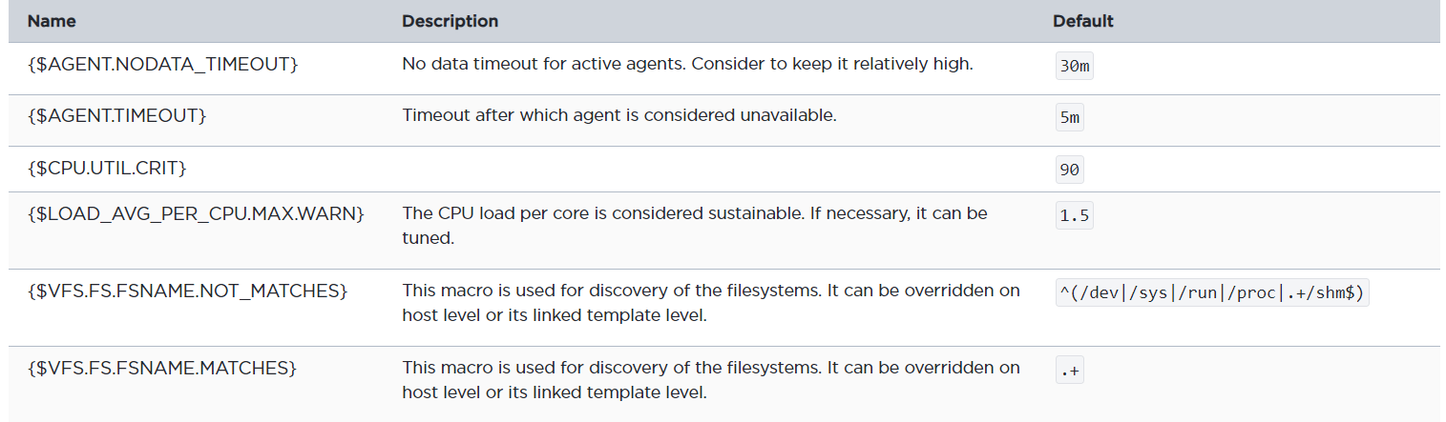

Refer here for official docs: [Linux by Zabbix agent active](https://www.zabbix.com/integrations/linux#linux_active)

9.3 Nginx by HTTP:

Nginx is a web server which can also be used as a reverse proxy, load balancer, mail proxy and HTTP cache. The software was publicly released in 2004. A company of the same name was founded in 2011 to provide support and Nginx plus paid software.

The template Nginx by HTTP - collects metrics by polling the [Module ngx_http_stub_status_module](https://nginx.ru/en/docs/http/ngx_http_stub_status_module.html) with HTTP agent remotely:

### Macros used:

| Name | Description | Default |
| --- | --- | --- |
| {$NGINX.STUB_STATUS.SCHEME} | The protocol http or https of Nginx stub_status host or container. | http |
| {$NGINX.STUB_STATUS.PATH} | The path of the Nginx stub_status page. | basic_status |
| {$NGINX.STUB_STATUS.PORT} | The port of the Nginx stub_status host or container. | 80 |
| {$NGINX.RESPONSE_TIME.MAX.WARN} | The maximum response time of Nginx expressed in seconds for a trigger expression. | 10 |
| {$NGINX.DROP_RATE.MAX.WARN} | The critical rate of the dropped connections for a trigger expression. | 1 |

Refer here for official docs: [Nginx by HTTP](https://www.zabbix.com/integrations/nginx#nginx_http)

# 9.4 Jenkins by HTTP:

Jenkins is a free and open-source automation server. It helps automate the parts of software development related to building, testing, and deploying, facilitating continuous integration and continuous delivery. It is a server-based system that runs in servlet containers such as Apache Tomcat.

Metrics are collected by requests to [Metrics API](https://plugins.jenkins.io/metrics/). For common metrics: Install and configure Metrics plugin parameters according [official documentations](https://plugins.jenkins.io/metrics/). Do not forget to configure access to the Metrics Servlet by issuing API key and change macro {$JENKINS.API.KEY}.

For monitoring computers and builds: Create API token for monitoring user according [official documentations](https://www.jenkins.io/doc/book/system-administration/authenticating-scripted-clients/) and change macro {$JENKINS.USER}, {$JENKINS.API.TOKEN}. Don't forget to change macros {$JENKINS.URL}.

### Macros used:

| Name | Description | Default |
| --- | --- | --- |
| {$JENKINS.URL} | Jenkins URL in the format <scheme>://<host>:<port> |  |
| {$JENKINS.API.KEY} | API key to access Metrics Servlet |  |
| {$JENKINS.USER} | Username for HTTP BASIC authentication | zabbix |
| {$JENKINS.API.TOKEN} | API token for HTTP BASIC authentication. |  |
| {$JENKINS.PING.REPLY} | Expected reply to the ping. | pong |
| {$JENKINS.FILE_DESCRIPTORS.MAX.WARN} | Maximum percentage of file descriptors usage alert threshold (for trigger expression). | 85 |
| {$JENKINS.JOB.HEALTH.SCORE.MIN.WARN} | Minimum job's health score (for trigger expression). | 50 |

Refer here for official docs: [Jenkins by HTTP](https://www.zabbix.com/integrations/jenkins)

# 9.5 Systemd by Zabbix agent 2:

systemd is a software suite that provides an array of system components for Linux operating systems. Its main aim is to unify service configuration and behavior across Linux distributions.

### Macros used:

| Name | Description | Default |
| --- | --- | --- |
| {$SYSTEMD.NAME.SOCKET.MATCHES} | Filter of systemd socket units by name | .* |
| {$SYSTEMD.NAME.SOCKET.NOT_MATCHES} | Filter of systemd socket units by name | CHANGE_IF_NEEDED |
| {$SYSTEMD.ACTIVESTATE.SOCKET.MATCHES} | Filter of systemd socket units by active state | active |
| {$SYSTEMD.ACTIVESTATE.SOCKET.NOT_MATCHES} | Filter of systemd socket units by active state | CHANGE_IF_NEEDED |
| {$SYSTEMD.UNITFILESTATE.SOCKET.MATCHES} | Filter of systemd socket units by unit file state | enabled |

Refer here for Official Docs: [Systemd by Zabbix Agent 2](https://www.zabbix.com/integrations/systemd)

# 9.6 Generic Java JMX:

Java Management Extensions (JMX) is a Java technology that supplies tools for managing and monitoring applications, system objects, devices and service-oriented networks. Those resources are represented by objects called MBeans. In the API, classes can be dynamically loaded and instantiated.

### Macros used:

| Name | Description | Default |
| --- | --- | --- |
| {$JMX.NONHEAP.MEM.USAGE.MAX} | A threshold in percent for Non-heap memory utilization trigger. | 85 |
| {$JMX.NONHEAP.MEM.USAGE.TIME} | The time during which the Non-heap memory utilization may exceed the threshold. | 10m |
| {$JMX.HEAP.MEM.USAGE.MAX} | A threshold in percent for Heap memory utilization trigger. | 85 |
| {$JMX.HEAP.MEM.USAGE.TIME} | The time during which the Heap memory utilization may exceed the threshold. | 10m |
| {$JMX.MP.USAGE.MAX} | A threshold in percent for memory pools utilization trigger. Use a context to change the threshold for a specific pool. | 85 |

|  |  |  |
| --- | --- | --- |
| {$JMX.USER} | JMX username. |  |
| {$JMX.PASSWORD} | JMX password. |  |

Refer here for Official Docs: [Java monitoring and integration with Zabbix](https://www.zabbix.com/integrations/java_monitoring)

# 9.7 Elasticsearch Cluster by HTTP

The template to monitor Elasticsearch by Zabbix that work without any external scripts. It works with both standalone and cluster instances. The metrics are collected in one pass remotely using an HTTP agent. They are getting values from REST API _cluster/health, _cluster/stats, _nodes/stats requests.

You can set {$ELASTICSEARCH.USERNAME} and {$ELASTICSEARCH.PASSWORD} macros in the template for using on the host level. If you use an atypical location ES API, don't forget to change the macros {$ELASTICSEARCH.SCHEME},{$ELASTICSEARCH.PORT}.

### Macros used:

| Name | Description | Default |
| --- | --- | --- |
| {$ELASTICSEARCH.USERNAME} | The username of the Elasticsearch. |  |
| {$ELASTICSEARCH.PASSWORD} | The password of the Elasticsearch. |  |
| {$ELASTICSEARCH.PORT} | The port of the Elasticsearch host. | 9200 |
| {$ELASTICSEARCH.SCHEME} | The scheme of the Elasticsearch (http/https). | http |
| {$ELASTICSEARCH.RESPONSE_TIME.MAX.WARN} | The ES cluster maximum response time in seconds for trigger expression. | 10s |

Refer here for official docs: [Elasticsearch Cluster by HTTP](https://www.zabbix.com/integrations/elasticsearch)

# 9.8 MSSQL by ODBC

Microsoft SQL Server is a relational database management system developed by Microsoft. As a database server, it is a software product with the primary function of storing and retrieving data as requested by other software applications—which may run either on the same computer or on another computer across a network.

For named instance set the value of {$MSSQL.INSTANCE} macro as MSSQL$instance name. In case if MSSQL was installed using default configuration do not change {$MSSQL.INSTANCE} macro value.

The "Service's TCP port state" item uses {HOST.CONN} and {$MSSQL.PORT} macros to check the availability of MSSQL instance. If your instance uses a non-default TCP port, set the port in your section of odbc.ini in the line Server = IP or FQDN name, port.

Macros Used:

| Name | Description | Default |
| --- | --- | --- |
| {$MSSQL.DSN} | System data source name. | <Put your DSN here> |
| {$MSSQL.USER} | MSSQL username. | <Put your username here> |
| {$MSSQL.PASSWORD} | MSSQL user password. | <Put your password here> |
| {$MSSQL.INSTANCE} | The instance name for the default instance is SQLServer. For named instance set the macro value as MSSQL$instance name. | SQLServer |
| {$MSSQL.PORT} | MSSQL TCP port. | 1433 |

Refer her for official docs: [MSSQL By ODBC](https://www.zabbix.com/integrations/mssql#mssql_odbc)

# 9.9 Website certificate by Zabbix agent 2

## **SSL**

Transport Layer Security, the successor of the now-deprecated Secure Sockets Layer, is a cryptographic protocol designed to provide communications security over a computer network.

The template to monitor TLS/SSL certificate on the website by Zabbix agent 2 that works without any external scripts. Zabbix agent 2 with the Web Certificate plugin requests certificate using the web.certificate.get key and returns JSON with certificate attributes.

### Macros used

| Name | Description | Default |
| --- | --- | --- |
| {$CERT.EXPIRY.WARN} | Number of days until the certificate expires. | 7 |
| {$CERT.WEBSITE.HOSTNAME} | The website DNS name for the connection. | <Put DNS name> |
| {$CERT.WEBSITE.PORT} | The TLS/SSL port number of the website. | 443 |
| {$CERT.WEBSITE.IP} | The website IP address for the connection. |  |

10 Frontend Sections:

### Menu structure

The Zabbix frontend menu has the following structure:

* Dashboards
* Monitoring
  + Problems
  + Hosts
  + Latest data
  + Maps
  + Discovery
* Services
  + Services
  + SLA
  + SLA report
* Inventory
  + Overview
  + Hosts
* Reports
  + System information
  + Scheduled reports
  + Availability report
  + Triggers top 100
  + Audit log
  + Action log
  + Notifications
* Data collection
  + Template groups
  + Host groups
  + Templates
  + Hosts
  + Maintenance
  + Event correlation
  + Discovery
* Alerts
  + Actions
    - Trigger actions
    - Service actions
    - Discovery actions
    - Auto registration actions
    - Internal actions
  + Media types
  + Scripts
* Users
  + User groups
  + User roles
  + Users
  + API tokens
  + Authentication
* Administration
  + General
    - GUI
    - Auto registration
    - Images
    - Icon mapping
    - Regular expressions
    - Trigger displaying options
    - Geographical maps
    - Modules
    - Other
  + Audit log
  + Housekeeping
  + Proxies
  + Macros
  + Queue
    - Queue overview
    - Queue overview by proxy
    - Queue details

10.1 Monitoring (problems):

The Monitoring menu is all about displaying data. Whatever information Zabbix is configured to gather, visualize and act upon, it will be displayed in the various sections of the Monitoring menu.

In Monitoring → Problems you can see what problems you currently have. Problems are those triggers that are in the "Problem" state.

By default, all new problems are classified as cause problems. It is possible to manually reclassify certain problems as symptom problem of the cause problem. For more details, see [cause and symptom events](https://www.zabbix.com/documentation/current/en/manual/web_interface/frontend_sections/monitoring/problems/cause_and_symptom).

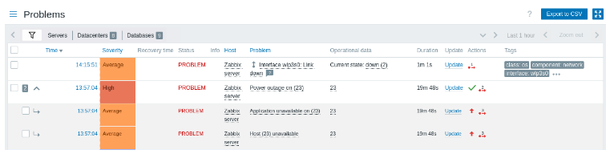

Problems has the following menu and the information.

Checkbox, Time, Severity, Recovery time, Status, Info, Host, Problem, Operational data, Duration, *Update,* Actions, Tags.

10.2 Hosts:

The Monitoring → Hosts section displays a full list of monitored hosts with detailed information about host interface, availability, tags, current problems, status (enabled/disabled), and links to easily navigate to the host's latest data, problem history, graphs, dashboards and web scenarios.

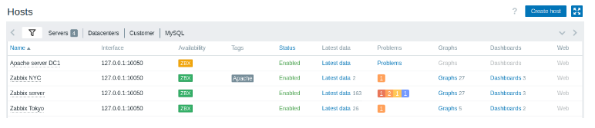

Problems has the following menu and the information.

Name, Interface, Availability, Tags, Status, Latest data, Problems, Graphs, Dashboards, web.

10.3 Latest Data:

In this section you can view the latest values gathered by items.

Graphs are also available for the item values.

This section contains:

* the [filter](https://www.zabbix.com/documentation/current/en/manual/web_interface/frontend_sections/monitoring/latest_data#using-filter) (collapsed by default)
* the [subfilter](https://www.zabbix.com/documentation/current/en/manual/web_interface/frontend_sections/monitoring/latest_data" \l "using-subfilter) (never collapsed)
* the item list

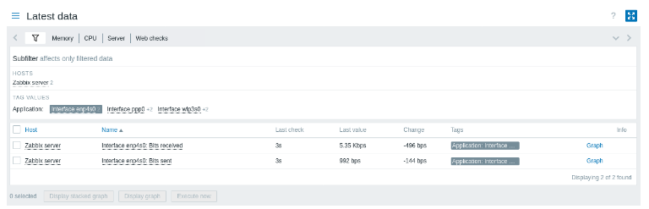

Items are displayed with their name, time since the last check, **last value**, change amount, tags, and a link to a simple graph/history of item values.

Values in the Last value column are displayed with unit conversion and value mapping applied. To view raw data, hover over the value.

Tags in the item list are clickable. If you click on a tag, this tag becomes enabled in the [subfilter](https://www.zabbix.com/documentation/current/en/manual/web_interface/frontend_sections/monitoring/latest_data" \l "using-subfilter). The item list now displays the items corresponding to this tag and any other previously selected tags in the subfilter. Note that once the items have been filtered in this way, tags in the list are no longer clickable. Further modification based on tags (e.g., remove, add another filter) must be done in the subfilter.

If an item has errors, for example, has become unsupported, an information icon will be displayed in the Info column . Hover over the icon for details.

An icon with a question mark  is displayed next to the item name for all items that have a description. Hover over this icon to see a tooltip with the item description.

10.4 Maps:

In the Monitoring → Maps section you can configure, manage and view [network maps](https://www.zabbix.com/documentation/current/en/manual/config/visualization/maps).

When you open this section, you will either see the last map you accessed or a listing of all maps you have access to.

All maps can be either public or private. Public maps are available to all users, while private maps are accessible only to their owner and the users the map is shared with.

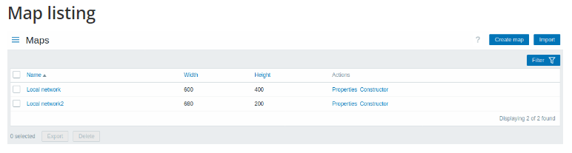

Displayed data:

|  |  |
| --- | --- |
| Name | Name of the map. Click on the name to [view](https://www.zabbix.com/documentation/current/en/manual/web_interface/frontend_sections/monitoring/maps#viewing-maps) the map. |
| Width | Map width is displayed. |
| Height | Map height is displayed. |
| Actions | Two actions are available: **Properties** - edit general map [properties](https://www.zabbix.com/documentation/current/en/manual/config/visualization/maps/map#creating-a-map) **Constructor** - access the grid for adding [map elements](https://www.zabbix.com/documentation/current/en/manual/config/visualization/maps/map#adding-elements) |

To [configure](https://www.zabbix.com/documentation/current/en/manual/config/visualization/maps/map#creating-a-map) a new map, click on the Create map button in the top right-hand corner. To import a map from a YAML, XML, or JSON file, click on the Import button in the top right-hand corner. The user who imports the map will be set as its owner.

# 11 Zabbix Alerts: Setup Zabbix Email Notifications

11.1 Office365:

Media are the delivery channels used for sending notifications and alerts from Zabbix.

Media types are configured in **Alerts → Media types.**

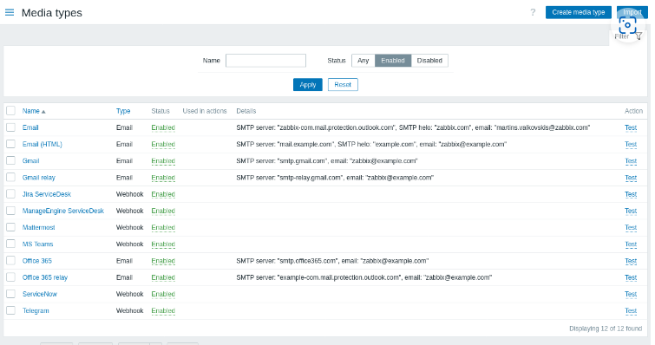

When selecting the Gmail/Office365 related options, it is only required to supply the sender email address/password to create a work.

#### **Configuration**

To configure email as the media type:

* Go to Alerts → Media types
* Click on Create media type (or click on Email in the list of pre-defined media types).

The **Media type** tab contains general media type attributes:

**Note**: All mandatory input fields are marked with a red asterisk.

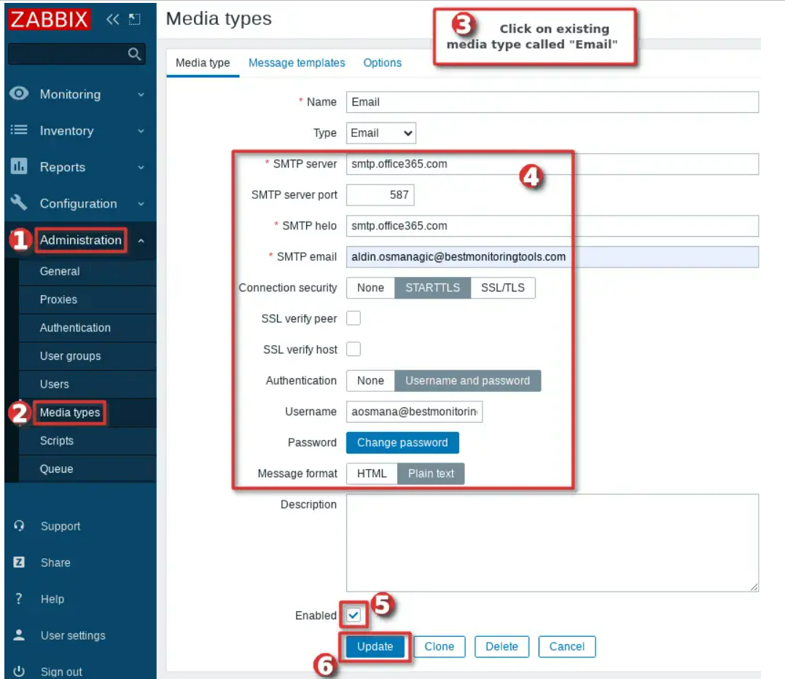

Follow the quick guide in the image above or use the detailed steps below to configure Zabbix media type to send alerts via email through your Office 365 mail account:

* Use the default media type called “*Email*” that comes with Zabbix (or create a new one) under the section “*Administration*” → “*Media types* “.
* Set “*SMTP server*” to **smtp.office365.com** to handle outgoing emails
* Set “*SMTP server port*” to **port 587**
* Set “*SMTP hello*” to **smtp.office365.com**
* Set your Office 365 email in the “*SMTP email*” field that Zabbix will use as the “***From****address*” in the outgoing emails (i.e., *zabbix_mycompany@mycompany.com*). You can also force a display name if you put an email address in the format “*Zabbix_Info <zabbix_mycompany@mycompany>*” (without quotes).
* Select “*STARTTLS*” option under the “*Connection security*” section
* Select “*Username and password*” under the “Authentication” section
* Set your Office 365 account email as “*Username* “, but make sure that you put here the main email that you use to login to Office 365 or you will receive “*Login denied*” error. Your login Office 365 username and email are usually identical, but sometimes, like in my example, they may be different.
* Set your Office 365 account password in the “*Password*” section
* Select “*Message format* “, use “*HTML*” or “*Plain text*” (default)
* Enable this “*Media type*” by clicking “*Enabled*” option
* Hit the “*Update*” button.

#### Media type testing

To test whether a configured email media type works correctly:

* Locate the relevant email in the [list](https://www.zabbix.com/documentation/current/en/manual/config/notifications/media#overview) of media types.
* Click on Test in the last column of the list (a testing window will open).
* Enter a Send to recipient address, message body and, optionally, subject.
* Click on Test to send a test message.

Test success or failure message will be displayed in the same window:

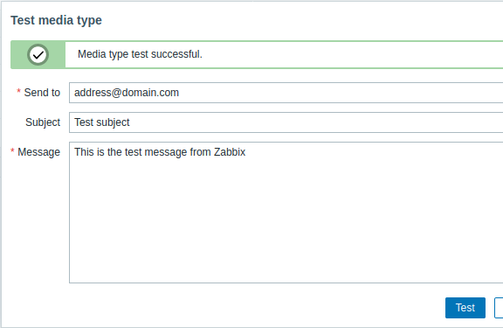

Office365 Mail alert:

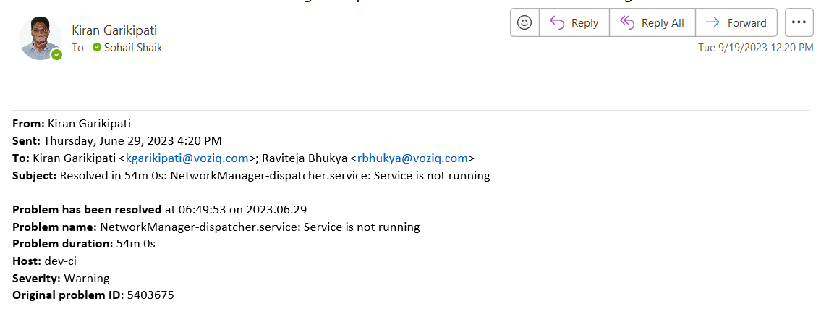

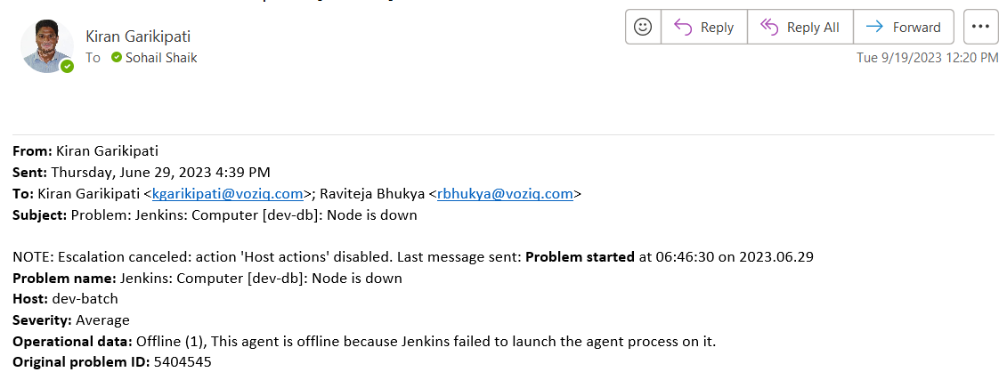

11.2 Webhook-Telegram:

The webhook media type is useful for making HTTP calls using custom JavaScript code for straightforward integration with external software such as helpdesk systems, chats, or messengers. You may choose to import an integration provided by Zabbix or create a custom integration from scratch.

Refer here for official docs: [Telegram integration](https://git.zabbix.com/projects/ZBX/repos/zabbix/browse/templates/media/telegram/README.md?at=refs%2Fheads%2Frelease%2F6.4)

## **Implementation Guide:**

### **Step 1: Create a Bot on Telegram**

To connect with **@BotFather** to get a **Token**, go to Telegram => search **@BotFather** and select **@BotFather** with a tick [√](https://cln.sh/bIJC0G) as shown below. Or you can go directly to <https://telegram.me/BotFather> link to connect with **@BotFather**.

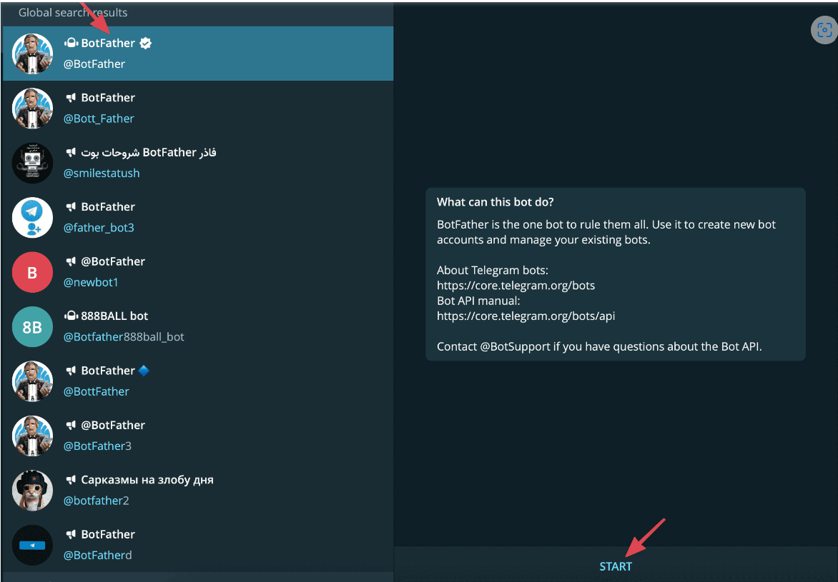

Press START to start the conversation.

Type **/newbot** to create a new bot.



Next, you enter a name for the bot to create (Note: the bot name must end with the word Bot. For example, **kbazBot** )

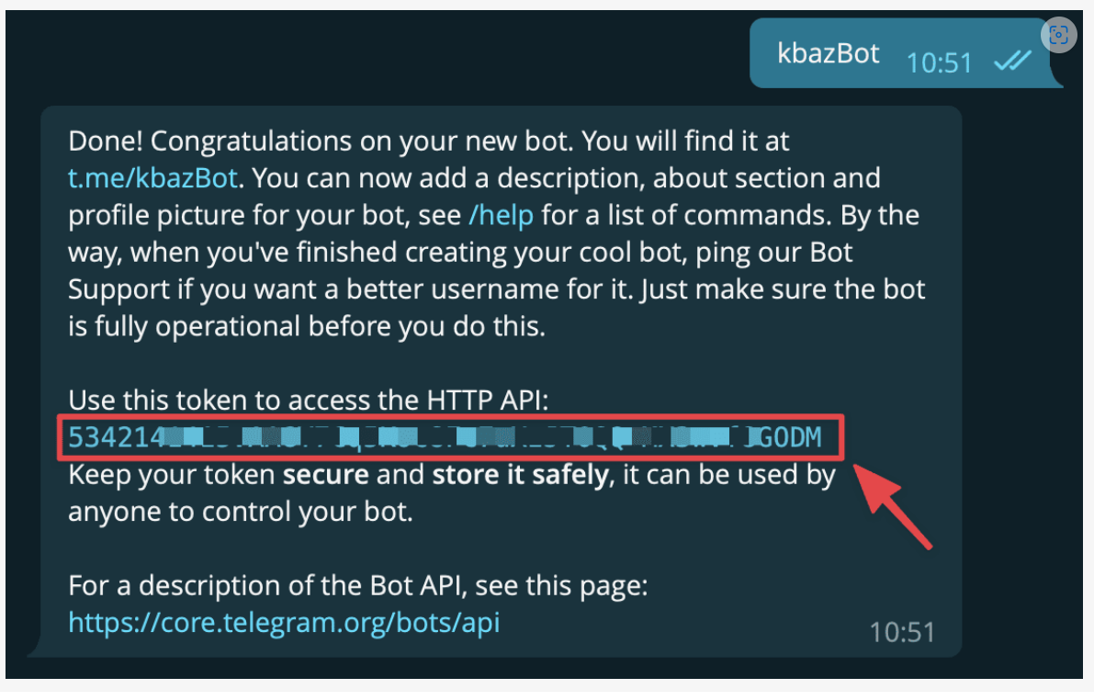

After successfully entering the Bot name, you will be provided with **Token to access HTTP API** as shown above (red frame). You proceed to save this Token segment.

Then you press START bot just created for it to work.

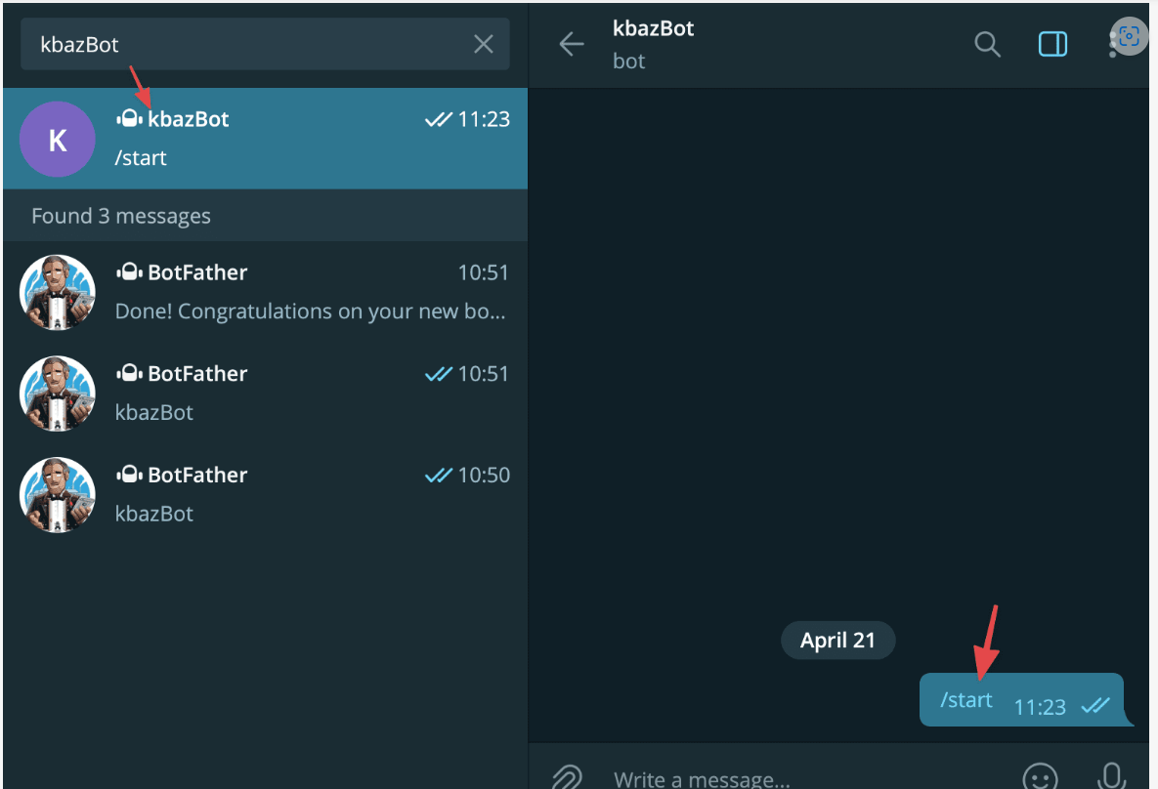

### **Step 2: Instructions to get ChatID on Telegram**

Next, you need to get the Bot ID and ID Groups.

* **Get Bot ID**

To get IDBot, go to Telegram => search for **IDBot** and press **START** to start chatting.

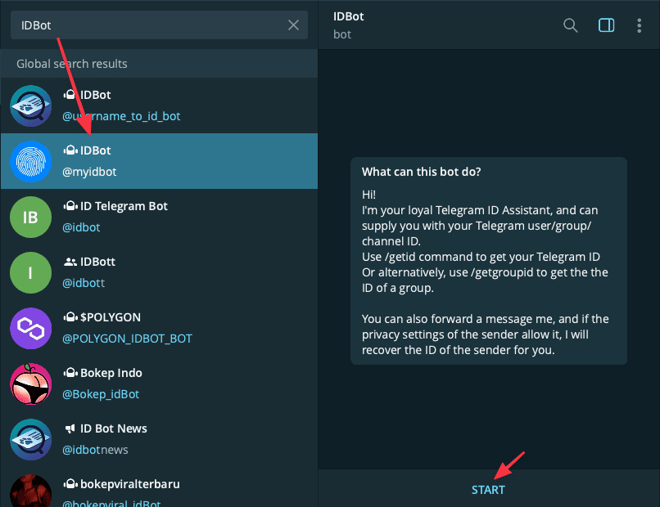

Next, type **/getid** to get the Bot’s ID, the ID will be in the form of numbers as shown below:

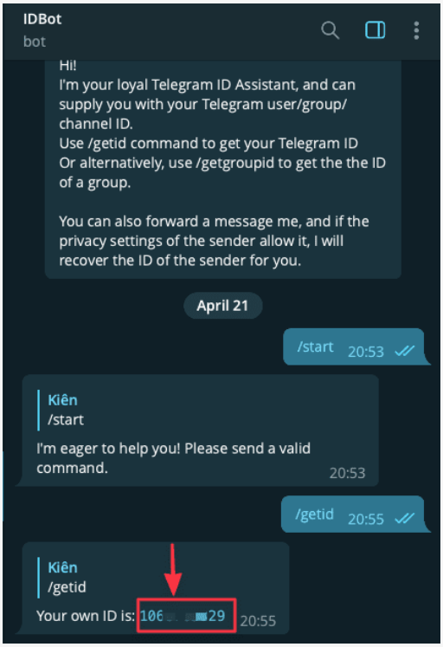

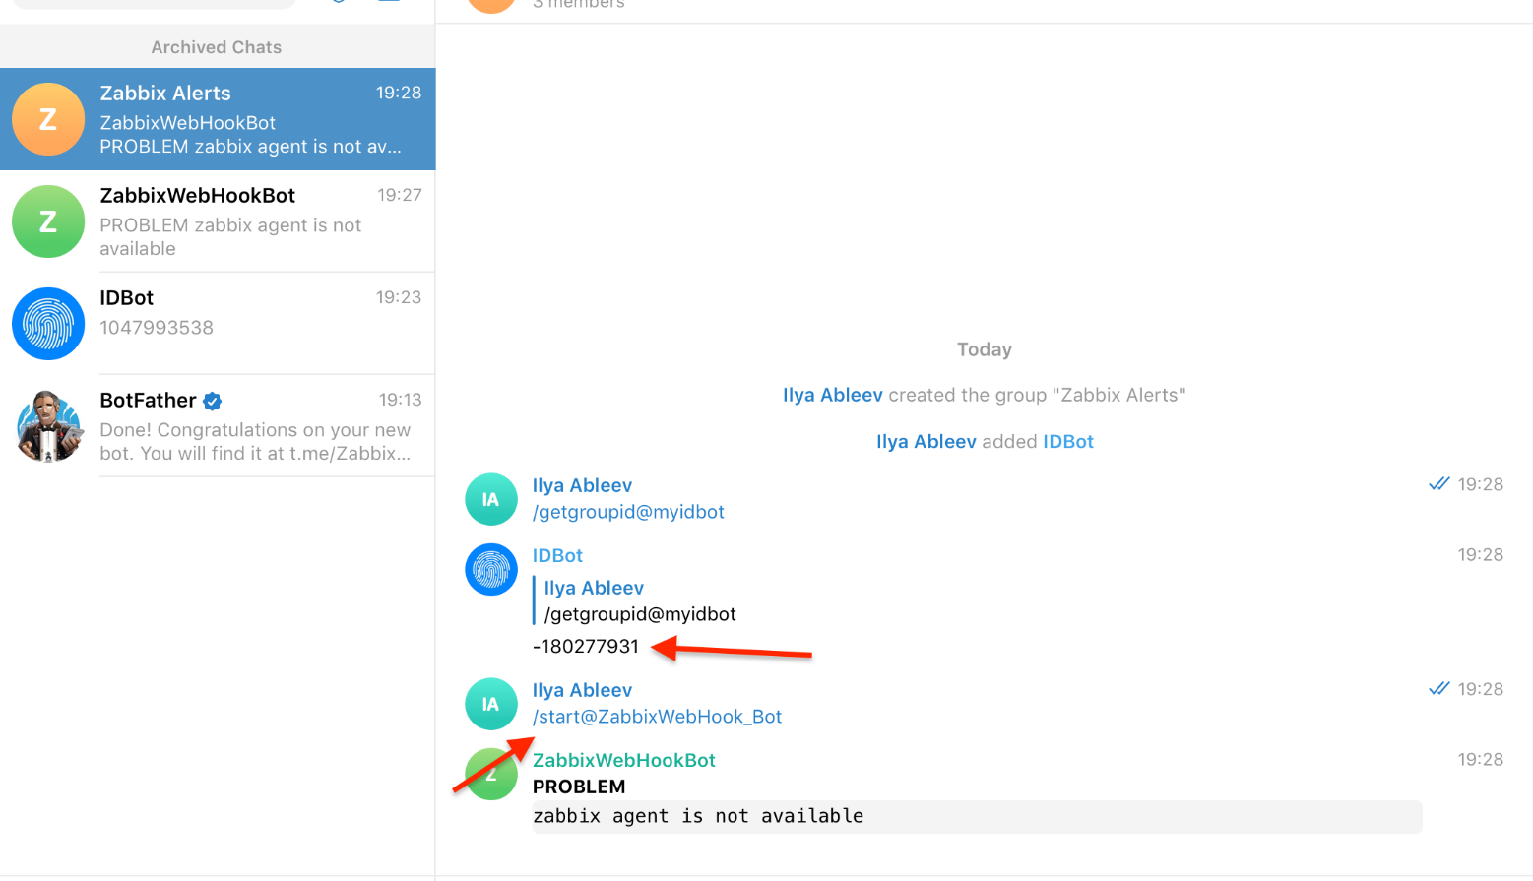

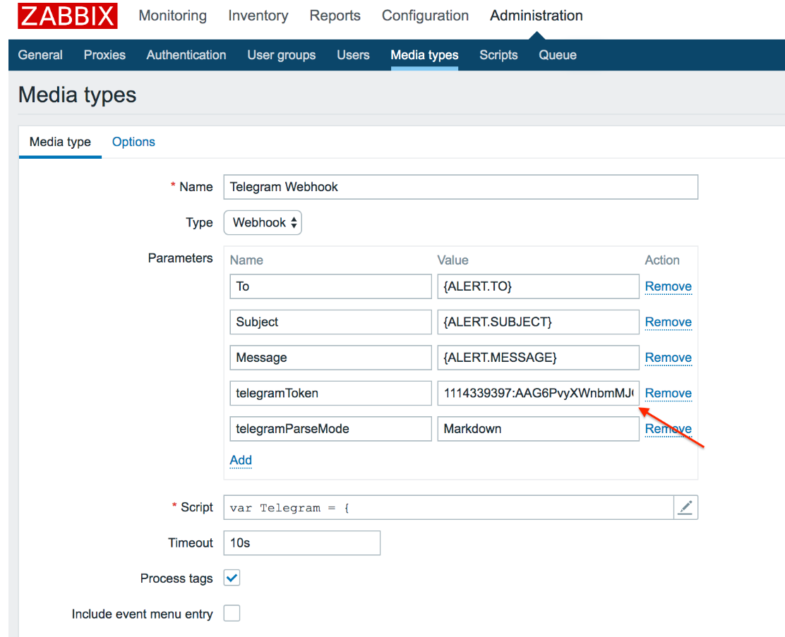

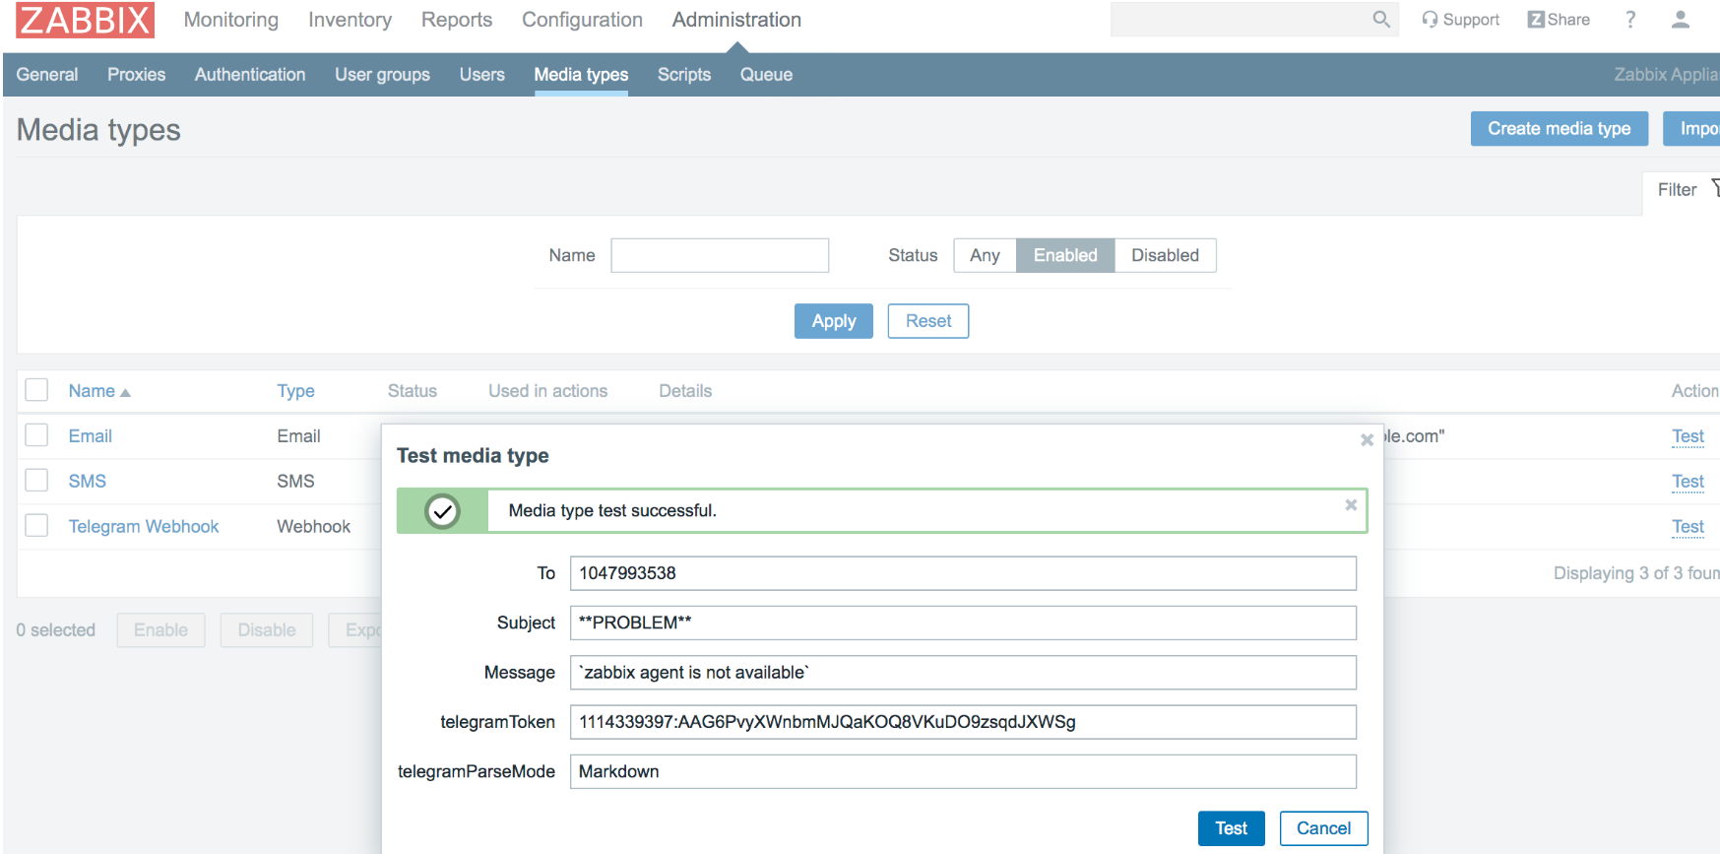

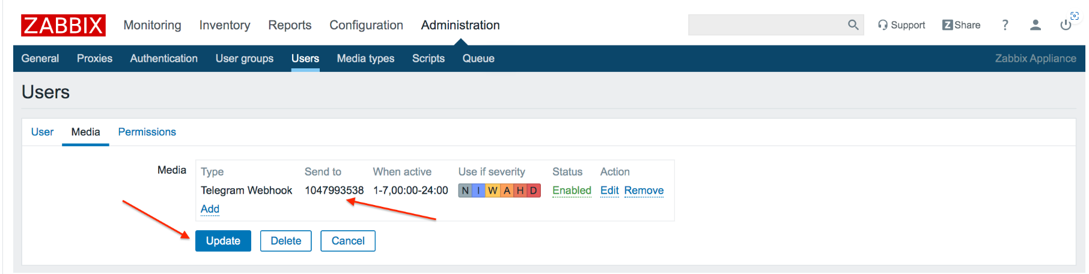

Telegram alert message:

Alert message for CPU utilization and disk usage:

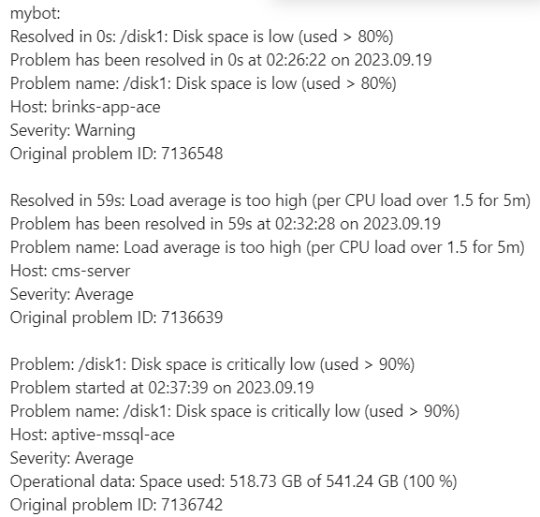

Alert message for MSSQL too many reads:

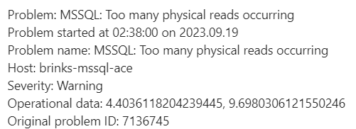

12. Authentication.

The Users → Authentication section allows to specify the user authentication method for Zabbix and internal password requirements.

The available authentication methods are internal, HTTP, LDAP, and SAML authentication.

#### **Default authentication:**

By default, Zabbix uses **internal** Zabbix authentication for all users.

SAML:

SAML 2.0 [authentication](https://www.zabbix.com/documentation/current/en/manual/web_interface/frontend_sections/users/authentication) can be used to sign in to Zabbix.

If only SAML sign-in is configured, then the user must also exist in Zabbix, however, its Zabbix password will not be used. If authentication is successful, then Zabbix will match a local username with the username attribute returned by SAML.

#### **User provisioning**

It is possible to configure JIT (just-in-time) **user provisioning** for SAML users. In this case, it is not required that a user already exists in Zabbix. The user account can be created when the user logs into Zabbix for the first time.

Note: If JIT provisioning is enabled, a user group for deprovisioned users must be specified in the Authentication tab.

On top of JIT provisioning, it is also possible to enable and configure SCIM (System for Cross-domain Identity Management) provisioning - continuous user account management for those users that have been created by user provisioning. SCIM provisioning requires a Zabbix [API token](https://www.zabbix.com/documentation/current/en/manual/web_interface/frontend_sections/users/api_tokens) (with Super admin permissions) for authentication into Zabbix.

For example, if a user is moved from one SAML group to another, the user will also be moved from one group to another in Zabbix; if a user is removed from a SAML group, the user will also be removed from the group in Zabbix and, if not belonging to any other group, added to the user group for deprovisioned users.

If SCIM is enabled and configured, a SAML user will be provisioned at the moment the user logs into Zabbix and continuously updated based on changes in SAML. Already existing SAML users will not be provisioned, and only provisioned users will be updated. Note that only valid media will be added to a user when the user is provisioned or updated.

If SCIM is not enabled, a SAML user will be provisioned (and later updated) at the moment the user logs into Zabbix.

**Note:** If SAML authentication is enabled, users will be able to choose between logging in locally or via SAML single sign-on. If JIT provisioning is used, then only single sign-on is possible.

#### **Setting up Zabbix:**

**Note:** It is required to install php-openssl if you want to use SAML authentication in the frontend.

To use SAML authentication Zabbix should be configured in the following way:

1. Private key and certificate should be stored in the ui/conf/certs/, unless custom paths are provided in [zabbix.conf.php](https://www.zabbix.com/documentation/current/en/manual/web_interface/frontend_sections/users/authentication/authentication#advanced-settings).

By default, Zabbix will look in the following locations:

* ui/conf/certs/sp.key - SP private key file
* ui/conf/certs/sp.crt - SP cert file
* ui/conf/certs/idp.crt - IDP cert file

 All of the most important settings can be configured in the Zabbix frontend. However, it is possible to specify additional settings in the [configuration file](https://www.zabbix.com/documentation/current/en/manual/web_interface/frontend_sections/users/authentication/authentication#advanced-settings).

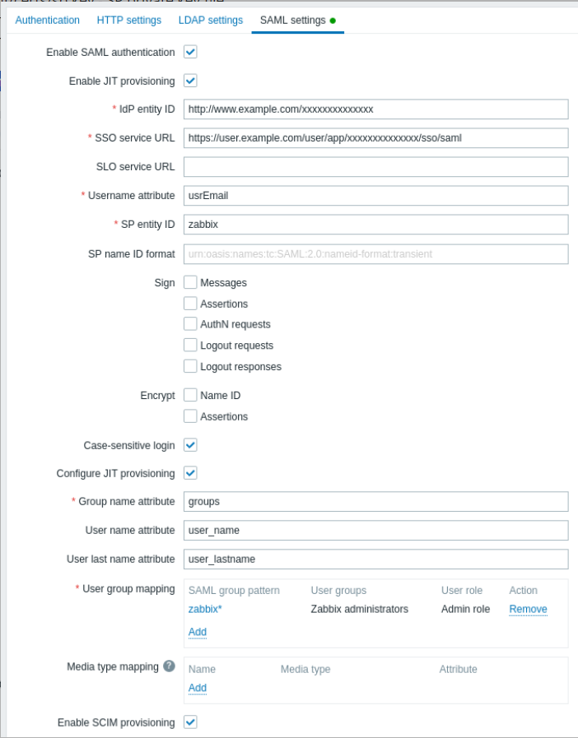

See examples of configuring SAML identity providers for sign-in and user provisioning into Zabbix with:

* [Microsoft Azure AD](https://www.zabbix.com/documentation/current/en/manual/appendix/install/azure_ad)

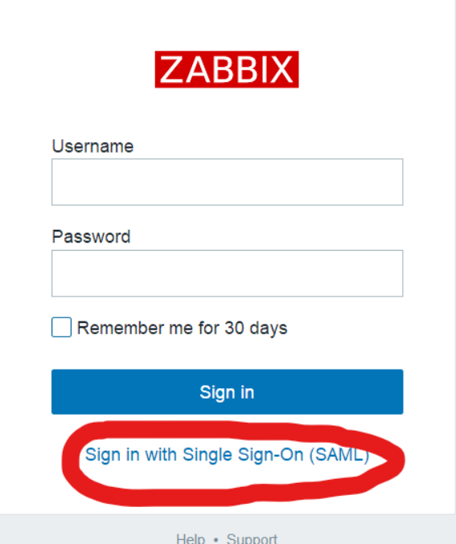

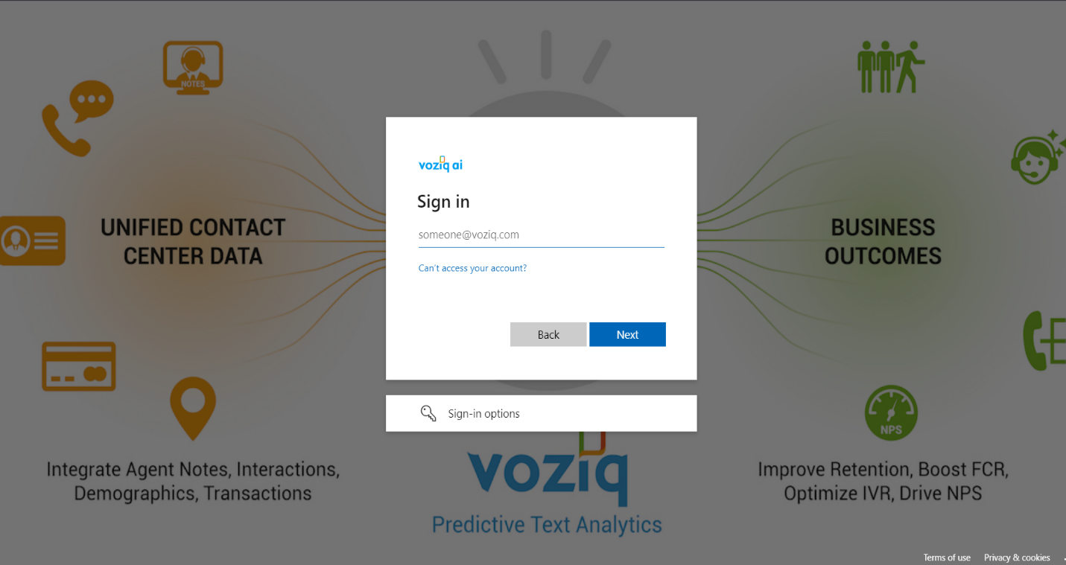

13 User Groups:

#### Overview

In the Users → User groups section user groups of the system are maintained.

#### User groups

A listing of existing user groups with their details is displayed.

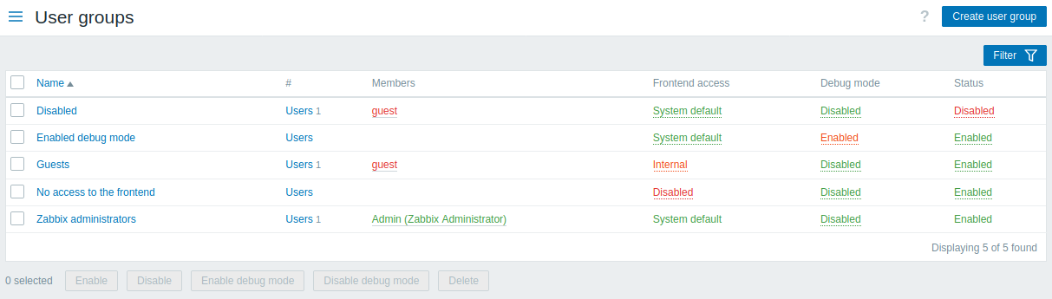

##### Mass editing options

Buttons below the list offer some mass-editing options:

* Enable - change the user group status to Enabled
* Disable - change the user group status to Disabled
* Enable debug mode - enable debug mode for the user groups
* Disable debug mode - disable debug mode for the user groups
* Delete - delete the user groups

To use these options, mark the checkboxes before the respective user groups, then click on the required button.

##### Using filter

You can use the filter to display only the user groups you are interested in. For better search performance, data is searched with macros unresolved.

The Filter link is available above the list of user groups. If you click on it, a filter becomes available where you can filter user groups by name and status.



13.1 User roles:

#### Overview

In the Users → User roles section you may create user roles.

User roles allow to create fine-grained permissions based on the initially selected user type (User, Admin, Super admin).

Upon selecting a user type, all available permissions for this user type are granted (checked by default).

Permissions can only be revoked from the subset that is available for the user type; they cannot be extended beyond what is available for the user type.

Checkboxes for unavailable permissions are grayed out; users will not be able to access the element even by entering a direct URL to this element into the browser.

User roles can be assigned to system users. Each user may have only one role assigned.

#### **Default user roles:**

By default, Zabbix is configured with four user roles, which have a pre-defined set of permissions:

* Guest role
* User role
* Admin role
* Super admin role

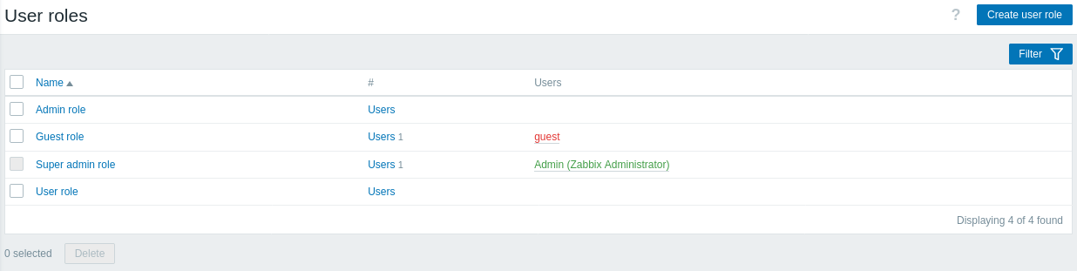

These are based on the main user types in Zabbix. The list of all users assigned the respective role is displayed. The users included in disabled groups are stated in red. The Guest role is a user-type role with the only permissions to view some frontend sections.

**Note**: The default Super admin role cannot be modified or deleted, because at least one Super admin user with unlimited privileges must exist in Zabbix. Users of type Super admin can modify settings of their own role, but not the user type.

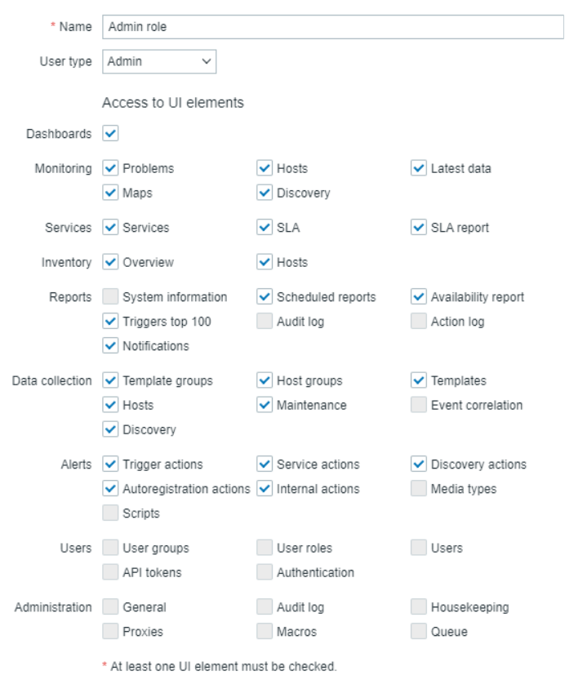

Refer Here for the Default [Permissions for guest,user,admin,super admin.](https://www.zabbix.com/documentation/current/en/manual/web_interface/frontend_sections/users/user_roles)

Available permissions are displayed. To revoke a certain permission, unmark its checkbox.

Available permissions along with the defaults for each pre-configured user role in Zabbix are described below.

13.2 Users:

#### Overview

In the Users → Users section users of the system are maintained.

#### Users

A listing of existing users with their details is displayed.

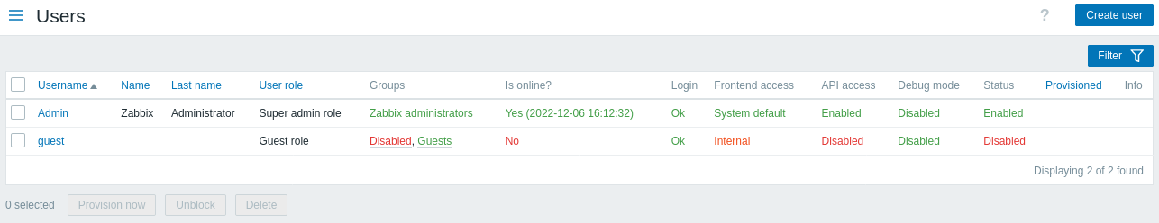

##### Mass editing options

Buttons below the list offer some mass-editing options:

* Provision now - update user information from LDAP (this option is only enabled if an LDAP user is selected)
* Unblock - re-enable system access to blocked users
* Delete - delete the users

To use these options, mark the check-boxes before the respective users, then click on the required button.

##### Using filter

The Filter link is available above the list of users. If you click on it, a filter becomes available where you can filter users by username, name, last name, user role and user group.



14 Dashboards:

The Monitoring → Dashboard section is designed to display summaries of all the important information.

A dashboard consists of widgets and each widget is designed to display information of a certain kind and source, which can be a summary, a map, a graph, the clock, etc.

Access to hosts in the widgets depends on host [permissions](https://www.zabbix.com/documentation/4.0/en/manual/config/users_and_usergroups/permissions#permissions-to-groups).

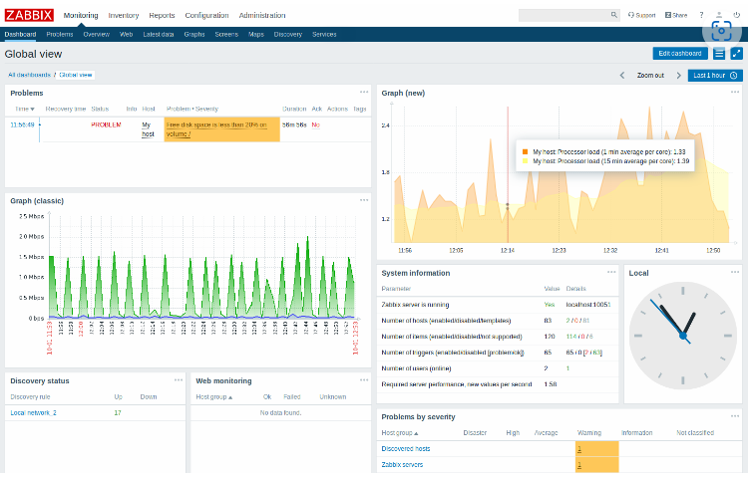

14.1 Global Dashboard

Zabbix Dashboard is a central place in the web frontend and provides high-level personalized details about the monitored environment:

* Favorite maps
* Favorite graphs
* Favorite screens

* Last 20 issues
* System status
* Host status

* Status of Zabbix server
* Discovery status
* Web monitoring

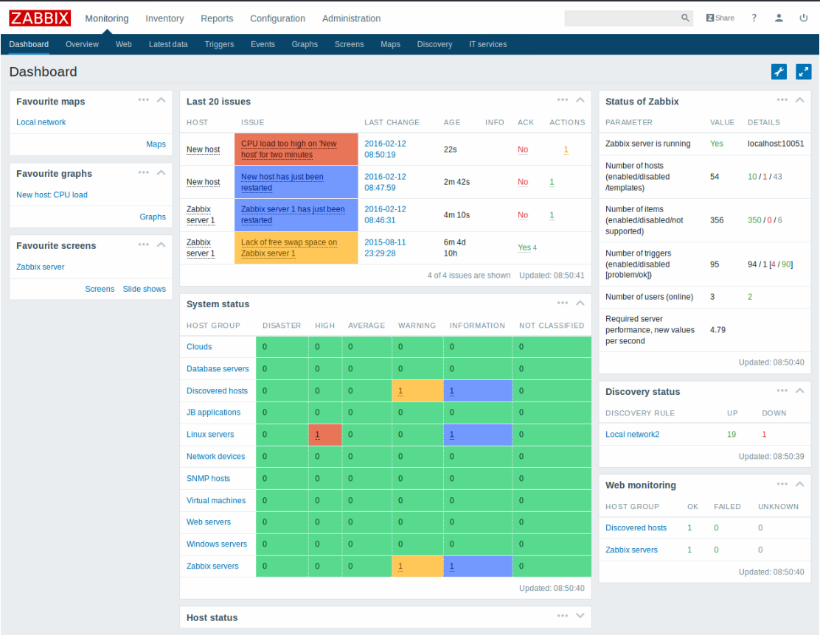

Dashboard can be filtered by host group, trigger severity, problem status and other parameters.

Users may customize the dashboard, reallocate widgets with drag-and-drop, add and remove favorites.

14.2 Creating a Dashboard:

When viewing all dashboards, you can click on the Create dashboard button to create a new dashboard:

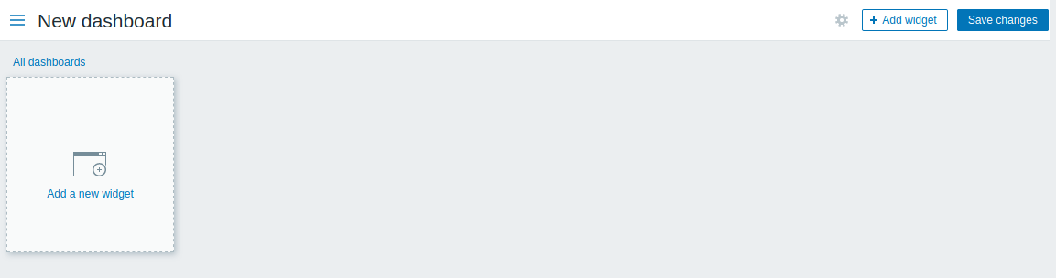

Initially the dashboard is empty. To populate the dashboard, you can add widgets.

Click on the Save changes button to save the dashboard. If you click on Cancel, the dashboard will not be created.

#### Adding widgets

To add a widget to a dashboard:

* Click on the Add widget button in dashboard editing mode. The widget will be created in its default size and placed after the existing widgets (if any);

Or

* Move your mouse to the desired empty spot for the new widget. Notice how a placeholder appears, on mouseover, on any empty slot on the dashboard. Then click to open the widget configuration form. After filling the form the widget will be created in its default size or take up all the available space if its default size is bigger. Alternatively, you may click and drag the placeholder to the desired widget size, then release. (When releasing you may need to click on *Add widget* if the *Paste widget* from a copied widget option is also available.)



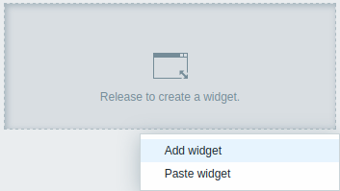

Then, in the widget configuration form:

* Select the *Type* of widget
* Enter widget parameters
* Click on *Add*

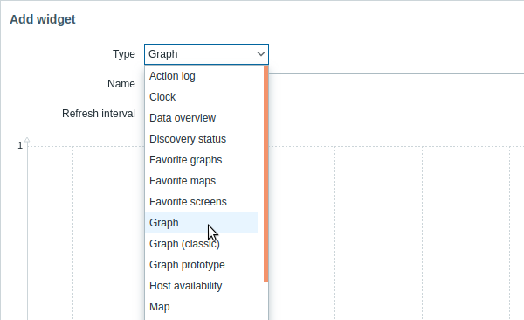

Here comes the screen in the network.

**Group:** We select the group with your servers.

**Host:** We select the relevant machine.

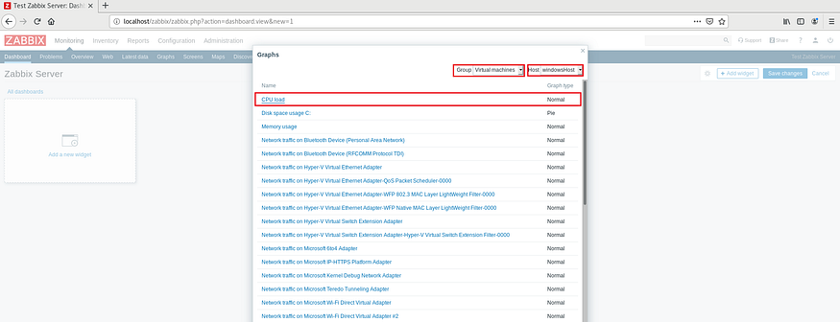

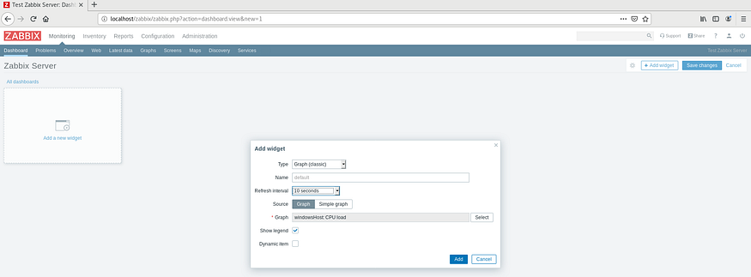

After this process, we can see our chart as follows.

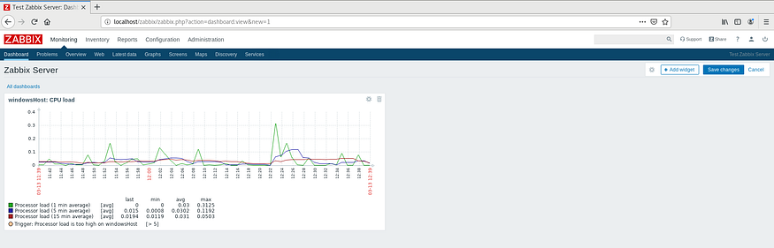

We do this in RAM, Network and Disk and get a graphic like the one below.

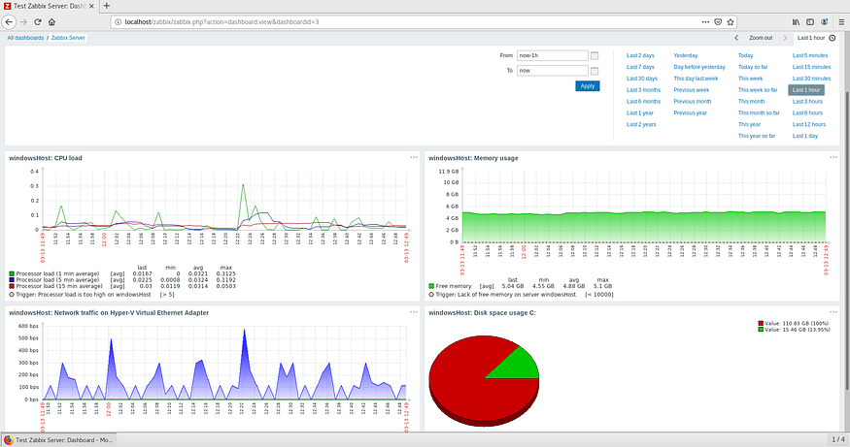

You can follow the instant system activities of all your devices on a single page that will repeat this process for each machine we have installed on the server.